

UNIVERSITY OF KWAZULU NATAL SCHOOL OF MATHEMATICS, STATISTICS AND COMPUTER SCIENCE

**Comparison of Metaheuristic Approaches for Blood Assignment Problems**

*Author*: Prinolan Govender *Supervisor*: A. Ezugwu

A THESIS SUBMITTED IN FULFILLMENT OF THE REQUIREMENTS FOR THE DEGREE OF MASTERS OF SCIENCE IN THE UNIVERSITY OF KWAZULU-NATAL SCHOOL OF MATHEMATICS,

STATISTICS AND COMPUTER SCIENCE

**List of figures**

|  |  |
| --- | --- |
| Figure | Description |
| 1 | Illustrates the FIFO system for blood unit distribution. |
| 2 | Flowchart representation of the daily events that occur within the blood bank |
| 3 | Flowchart representation of the steps conducted in this study |
| 4 | Pie chart representation of race groups in South Africa |
| 5 | Chromosome/Individual representation |
| 6 | Example of crossing over mechanism |
| 7 | Example of mutation mechanism |
| 8 | Line graph over a period of 365 days for the GA implementation of dataset 1 |
| 9 | Line graph over a period of 365 days for the PSO implementation of dataset 1 |
| 10 | Line graph over a period of 365 days for the DA implementation of dataset 1 |
| 11 | Line graph over a period of 365 days for the SOS implementation of dataset 1 |
| 12 | Line graph over a period of 365 days for the GWO implementation of dataset 1 |
| 13 | Line graph over a period of 365 days for the GA implementation of dataset 2 |
| 14 | Line graph over a period of 365 days for the PSO implementation of dataset 2 |
| 15 | Line graph over a period of 365 days for the DA implementation of dataset 2 |
| 16 | Line graph over a period of 365 days for the SOS implementation of dataset 2 |
| 17 | Line graph over a period of 365 days for the GWO implementation of dataset 2 |
| 18 | Line graph over a period of 365 days for the GA implementation of dataset 3 |
| 19 | Line graph over a period of 365 days for the PSO implementation of dataset 3 |
| 20 | Line graph over a period of 365 days for the DA implementation of dataset 3 |
| 21 | Line graph over a period of 365 days for the SOS implementation of dataset 3 |
| 22 | Line graph over a period of 365 days for the GWO implementation of dataset 3 |
| 23 | Line graph over a period of 365 days for the GA implementation of dataset 4 |
| 24 | Line graph over a period of 365 days for the PSO implementation of dataset 4 |
| 25 | Line graph over a period of 365 days for the DA implementation of dataset 4 |
| 26 | Line graph over a period of 365 days for the SOS implementation of dataset 4 |
| 27 | Line graph over a period of 365 days for the GWO implementation of dataset 4 |
| 28 | Line graph over a period of 365 days for the GA implementation of dataset 5 |
| 29 | Line graph over a period of 365 days for the PSO implementation of dataset 5 |
| 30 | Line graph over a period of 365 days for the DA implementation of dataset 5 |
| 31 | Line graph over a period of 365 days for the SOS implementation of dataset 5 |
| 32 | Line graph over a period of 365 days for the GWO implementation of dataset 5 |
| 33 | Line graph over a period of 365 days for the GA implementation of dataset 6 |
| 34 | Line graph over a period of 365 days for the PSO implementation of dataset 6 |
| 35 | Line graph over a period of 365 days for the DA implementation of dataset 6 |
| 36 | Line graph over a period of 365 days for the SOS implementation of dataset 6 |
| 37 | Line graph over a period of 365 days for the GWO implementation of dataset 6 |
| 38 | Line graph over a period of 365 days for demand generation for GA |
| 39 | Line graph over a period of 365 days for demand generation for PSO |
| 40 | Line graph over a period of 365 days for demand generation for DA |
| 41 | Line graph over a period of 365 days for demand generation for SOS |
| 42 | Line graph over a period of 365 days for demand generation for GWO |

**List of tables**

|  |  |
| --- | --- |
| Table | Description |
| 1 | Blood compatibility representation |
| 2 | Blood proportions in South Africa |
| 3 | Terms from educational institutions in South Africa |
| 4 | Public holidays in South Africa |
|  |  |
|  |  |
|  |  |

**1. Introduction**

**1.1 Background**

Human blood management is characterized by a string of factors which can prove to be complicated over time [1]. Blood banks often face the scenario of insufficient whole blood (WB) units in storage to allocate to patients in need. A WB unit is comprised of four main components, with each component serving a specific purpose within the blood cell [2].

1. Red blood cell (RBC): Carries oxygen (O2) throughout the body, and removes Carbon Dioxide (CO2).
2. White blood cell (WBC): Fights against biological threats within the body, and are known as the body’s immune system.
3. Platelets (PLT): Seals of wounds and prevents bleeding.
4. Plasma: Transports nutrients and proteins to parts of the body, and holds RBC, WBC and PLT cells.

Majority of WB units in blood banks are usually attained through voluntary donations, after which starts the process of blood screening to identify any potential blood related threats which could harm the receiving patient. Any infected blood donations are immediately discarded, whilst the other donations deemed as clean, and stored in ideal conditions to be used for future distribution. It is possible for each component of a blood cell to be used individually for various medical scenarios, however this study will neglect the individual usage of blood components and focus on the overall WB unit. In accordance to the ABO blood system (a system used to classify the nature of an individual’s blood type) [3], blood within humans have four different blood groups, namely A, B, AB, O. With the introduction of a Rhesus (Rh) value which can either be positive (+) or negative (-) ends up doubling the initial blood groups which results in eight different blood types. The different blood types play a vital role with regards to storage, and distribution. In terms of storage, certain blood types are considered as rare, as very few individuals carry this particular blood type, for example the blood type *-* is extremely scarce within the South African population as 1% of the total population carry *AB-* blood. With regard to distribution, the relevance of blood types and compatibility plays an important role during transfusion. Cases have risen when medical knowledge was insufficient, where patients received incompatible blood types which has adverse health effects resulting in blood clumping (also referred to as agglutination), which can be life threatening.

The demand for WB units can be decomposed into two main scenarios. The first scenario relates to premeditated medical events which are in need of WB units, this can involve events such as general surgeries. Premeditated events allow the blood bank to allocate adequate amounts of WB units towards the desired patient, in addition if the blood banks have an inadequate amount of WB units to meet the demand, then it still leave the blood bank adequate time to import additional units from external sources. The second scenario relates to unforeseen patients who are in immediate need of WB units. Blood banks tend to struggle to fulfil this type of demand if a large influx of patients are in need of treatment involving blood units at the same time. Most blood banks tend to stock-pile WB units and other blood products during period of expected sudden trauma, however this is not a solution as demand for WB units can still out-weigh the on hand supply. The act of importing additional WB units raises the expenses incurred by the blood bank. Another factor which can contribute towards additional expenses relates to expiration of WB units. Expiry of units occurs when the WB units exceeds the expected shelf-life, the act of disposing the WB units in an appropriate manner increases the blood banks expenses. The act of freezing blood units can prolong the lifespan of the cells, however this study will ignore such WB units. The proposed blood assignment method generally seeks to minimize wastage of blood products by efficiently assigning blood to patient and preserving blood stock pile by allocating available blood to different blood types.

The blood assignment problem (BAP) is an optimization task which tries to efficiently assign WB units to patients in need, whilst trying to minimize the amount of importation and expiry within the blood bank. The BAP is comprised of a plethora of individual components which can demonstrate issues when trying to create a mathematical model. Such components include: daily demand, cross-matching blood types, importing additional blood units and expiring WB units when they have exceeded their shelf-life. In addition, the research conducted in this study is from a perspective of the South African National Blood Service (SANBS) and in relation to the South African population.

**1.2 Problem Statement**

The demand received for WB units must be met. With this in mind, if the daily demand exceeds the current supply on hand, then additional WB units must be imported from external sources in order to satisfy the demand. Blood banks receive WB units which are largely contributed from voluntary donations from donors. These fresh WB units enter a queuing system also referred to as the First-in First-out (FIFO) method, this implies that the oldest WB units would be used first with the newer units being placed at the back of the queue to be used at a later time. Below is Fig.1 which illustrates the process of using the FIFO system for distributing WB units.

Enter

Exit

WB Unit

Queue

Fig. 1: Illustration of the FIFO process for WB units

In Fig. 1, the round shapes represent WB units, with the numbers ranging from 1 to n, were n represents any positive integer. The WB units proceed to follow the queue until it exits, thus implying that the WB unit is being distributed to a patient. Note that Fig. 1 illustrates the queuing system for all blood types. The effect of implementing the FIFO system aims at minimizing expiry among WB units, as the oldest WB units are being utilised first, thus decreasing its exposure to storage time. Any WB units that have exceeded their respective shelf-life are discarded from storage, which is a negative connotation for the blood bank as this incurs additional expenses and implies that the blood bank is not utilises resources in an effective manner. It would be appropriate for a patient to receive blood relating to their specific type, however a situation might arise where there is an inadequate supply of WB units pertaining to that specific blood type. When this occurs, various processes occur to try and satisfy the demand. Firstly, the request will try to be satisfied by using other compatible blood types. Each blood type must first try and satisfy the demand pertaining to their own types, once their respective demands have been met, only then can the act compatibility distribution can occur. compatibility distribution in this study relates to using the remaining units from each blood type and redistributing those units to other compatible blood types. The act of redistribution minimizes additional blood importation from external sources, and uses resources more effectively. However, if redistributing remaining WB units still cannot satisfy the demand in a day, only then would additional WB units be imported from external sources. The act of importing WB units incurs additional expenses for the blood bank, and must therefore be minimized. The BAP can be summarized into four major components.

1. Supply: Stock on hand at any given moment.
2. Demand: Relates to both planned and unplanned requests for WB units.
3. Importation: Utilizes additional WB units from external sources in order to satisfy a demand.
4. Expiry: Occurs when WB units exceed their shelf-life.

Fig. 2 is a flowchart depicting the steps taken each day within the blood bank for the management of WB units. In addition, it also illustrates the steps that must be fulfilled in order for additional WB unit importation to occur.

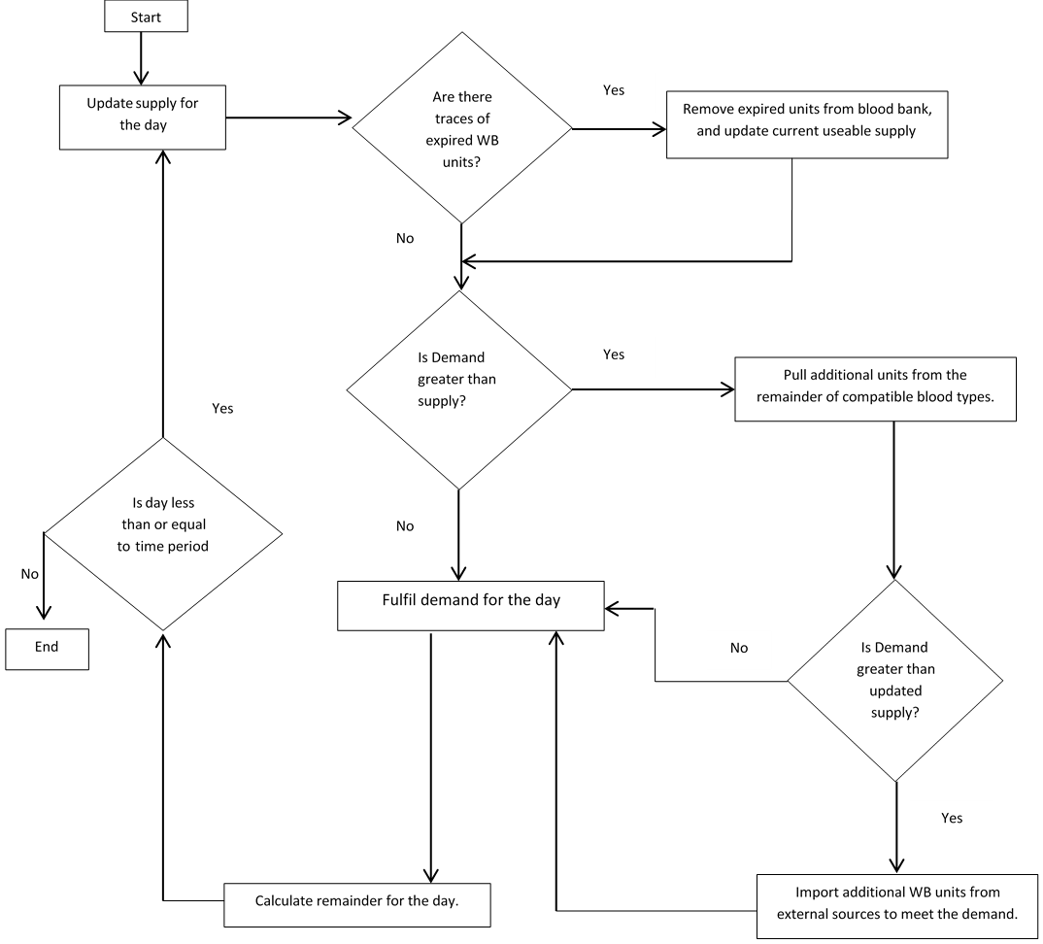

Fig 2: Flow diagram representing the daily processes that occur with the blood bank in this study

**1.3 Motivation**

The notion of optimization can successfully be applied to various complex decision making or allocation problems [4]. The BAP is considered as a NP-hard problem, due to the complexities associated with blood assignment [5]. Prior research specifically dedicated for the BAP is relatively scarce, with only a handful of research tackling the problem from an optimization perspective.

The importance of this study of the BAP tries to further develop a solid mathematical model, and explore different metaheuristic algorithms to work the BAP. The algorithms implemented in this study include: Genetic Algorithm (GA), Particle Swarm Optimization (PSO), Duelling Algorithm (DA), Symbiotic Organism Search (SOS), and the Grey Wolf Optimizer (GWO). The BAP can also be seen as a perishable inventory problem, this study can therefore contribute towards future research relating to blood and other relatable perishable inventory problems. Prior research suffered with the inability of using appropriate real-world datasets to examine their implementations for working the BAP. Due to confidentiality issues, this study also could not utilize real-world datasets. To confront this problem, datasets were stochastically generated, in addition this study tries to utilise events and statistics prevalent to South Africa. By utilising such factors, the datasets (even through randomly generated) can try to reduce such randomness when generating values for demand of WB units. The ideology behind generating datasets using a statistical approach lies behind social convention, the demand for WB units should have certain trends. For example, the demand for WB units should have a greater need during months that experience more public holidays or breaks from educational institutions due to higher levels of dangerous activity such as drink driving, and criminal activity.

Expenses are an aspect that must be within any organization, and SANBS is no different. In accordance to [5], SANBS require various equipment and chemicals in order to test and store WB units. Testing WB units is a vital component to any blood bank to ensure that the units are viable (Do not contain harmful diseases), and do not transmit any pathogens to receiving patients. A study conducted by [6] emphasized the four main activities related to blood and blood product management this includes:

1. **Production costs:** Relate to costs of running blood campaign collections, also included in this amount will be procedures in related to testing the WB units.
2. **Expiry costs:** WB units have a lifespan spanning between 30-35 days, once a WB unit has exceeded its lifespan, there are costs attached to incinerating the units.
3. **Inventory costs:** Costs associated with keeping WB units at optimum temperatures and in an adequate environment.
4. **Importation costs:** If in the event the supply at hand does not cover the demand for that day, additional WB units will have to be imported in order to fulfil the remaining demand.

This study will only focus on costs related to expiry and importation, as by minimizing the objective function of the BAP, this will relate in lower costs incurred by the blood bank.

**1.4 Aim and Objectives**

The primary objective of this project is to obtain an in-depth understanding of the BAP inventory management process. The work done in this study attempts to offer content which could possibly advance the research of the BAP or similar perishable inventory related problems. In addition, this study tries to implement a more accurate method when generating stochastic datasets. The following are some objectives that will be accomplished in this study.

1. Develop a robust blood bank management policy which aims at efficiently using WB units.
2. Implement five population-based metaheuristic algorithms to work the BAP. The algorithms include: GA, PSO, DA, SOS and GWO.
3. Generate a variety of stochastically based datasets which will examine how efficiently the blood bank is able to distribute WB units, and to test the levels of importation and expiry that might be faced. The datasets will embody various situations that the blood bank may experience during the course of its existence.
4. Implement a social aspect when generating datasets. This social component will be based from a South African perspective, and will incorporate such aspects like public holidays, and terms in educational institutions.
5. Analyse results achieved for each metaheuristic and document the results in a meaningful manner which will aid in determining the superior implementation for the BAP.

**1.5. Scope and limitations**

Due to the plethora of components that embody the BAP, certain assumptions will be introduced in order to develop a mathematical model that would be adequate for the problem at hand.

1. Race, gender, age and other contributing traits that characterize an individual will be ignored. The focus of the study is solely based on blood units.
2. All WB units will be deemed as “clean”, this means that no WB unit will contain pathogens.
3. A year will consist of 365 days.
4. The lifespan of a WB unit will be 30 days. This is in accordance to the study conducted by [7].
5. The first day (day 1) will have no carryover of WB units from the previous day.
6. All blood types will first fulfil requests associated with their blood types, from there the remainder from each blood group can contribute to other compatible blood types.

An additional limitation relates to the use of datasets in this study. Due to confidentiality issues, datasets where randomly generated using percentage bounds to generate values for supply. The concept of percentage bound is elucidated in chapter

**1.6. Methodology**

The BAP is comprised of various components that were examined individually in order to formulate a mathematical model. The methodology followed a step-by-step pattern as various components relied upon the previous steps in order to proceed. Below is fig.3 which illustrates a flow diagram of the steps conducted in this research of the BAP. The methodology consisted of seven main steps which will be expanded upon in later chapters.

Step 1: Obtain an in-depth understanding of blood banking, and implement an appropriate policy for issuing WB units.

Step 2: Conform the five metaheuristic algorithms to the chosen blood banking policy, in order to work the BAP.

Step 3: Since the datasets are stochastically generated, certain restrictions must be followed in order to mimic real life scenarios that may be faced by the blood bank at any given moment.

Step 4: In order to test how effectively each metaheuristic algorithm works the BAP, each algorithm will be subjected to the datasets.

Step 5: Computational results were used to determine the superiority of each algorithm. The assessment of each algorithm was based on the results obtained in correlation to the objective function of the BAP (further discussed in chapter 3).

Step 6: Record results in a manner that aids in identifying the better algorithm both analytically and visually.

Step 7: The records obtained from step 6 allowed for an extensive review of each metaheuristic algorithm which in turn revealed the best suited algorithm to work the BAP.

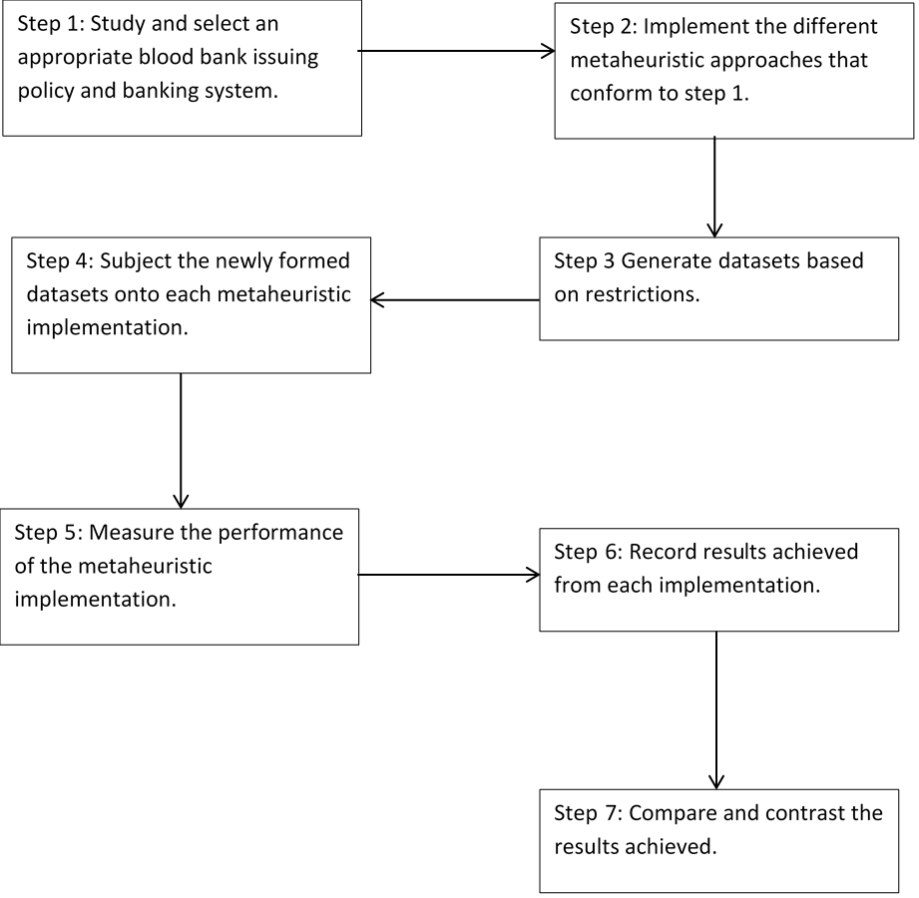

Fig. 3: Flowchart representation of the steps conducted in this study of the BAP.

**1.7 Thesis Layout**

The remainder of this Thesis will be organized as follows. Chapter 2 will extensively review prior literatures on the BAP. (Chapter 3 and 4 not really sure what to write here, don’t worry, I will adivse you later, we have them already). Whilst Chapter 5 will include the final remarks relating to the BAP in this study as well as future directions.

**2. Literature review**

The following chapter serves as some insight with regards to previous literatures that have studied the blood management process as well as research conducted in relation to the BAP. In order to understand the BAP, it is important to obtain an in-depth understanding with regards to individual components that compile the BAP. Due to the nature of data generation, it is also imperative to understand certain attributes which pertain to the South Africa population.

**2.1 Blood basics**

Blood transfusions save thousands of lives on a daily basis by means of medical treatment [8]. However, before divulging into the mathematical and computational components of prior research, blood itself has been extensively researched with the aim of improving health care for individuals. Experiments relating to blood transfusion was conducted in several steps, first blood was transfused between animals, and then from animal into man, with the first evidence of a transfusion occurring in 1666 within Oxford [9]. Since then the advancements of medical technology has assisted with the understanding of blood compatibility and transfusion. Using any incompatible blood type for transfusion often resulted in blood clumping and other negative side effects upon the patient. Back in 1927, antigens A and B where discovered followed by antigen O, which resulted in the widely known ABO blood grouping system [10]. With the introduction of an Rh value (mentioned in chapter 1), this further resulted to eight different blood types found in humans. Below is table 1 which illustrates the compatibility among blood types, note that “YES” implies that they are compatible, and “NO” indicates that they are not compatible.

Table 1: Representation of blood compatibility

|  |  |  |  |  |  |  |  |  |
| --- | --- | --- | --- | --- | --- | --- | --- | --- |
| Blood Types | A+ | A- | B+ | B- | AB+ | AB- | O+ | O- |
| A+ | YES | YES | NO | NO | NO | NO | YES | YES |
| A- | NO | YES | NO | NO | NO | NO | NO | YES |
| B+ | NO | NO | YES | YES | NO | NO | YES | YES |
| B- | NO | NO | NO | YES | NO | NO | NO | YES |
| AB+ | YES | YES | YES | YES | YES | YES | YES | YES |
| AB- | NO | NO | NO | YES | NO | YES | NO | YES |
| O+ | NO | NO | NO | NO | NO | NO | NO | YES |
| O- | NO | NO | NO | NO | NO | NO | NO | YES |

Even though blood is donated as whole units, the units can still be separated into its various components, these components can be used accordingly. For example, blood platelets can solely be utilized for patients with bleeding disorders [11]. The act of separating components for individual usage fully maximizes its utility at aiding patients with various health issues.

WB units are stored in freezers at certain temperatures in order to prolong their lifespan. Depending on the anticoagulant (a solution used to preserve WB units) used within the blood unit, temperatures inside these freezers range between 2-4 degrees Celsius with a lifespan ranging between 28-42 days [12]. Cryo-preservation relates to freezing WB units in order to drastically prolong their lifespan and can be viable for up to 10 years [13]. However the act of freezing can be time consuming and incur additional costs by the blood bank. These WB units also follow specific guidelines when thawing out and require sophisticated equipment during the cryo-preservation process.

**2.2 Overview of Metaheuristics**

The following study implemented a diverse ranged of nature inspired metaheuristics in order to work the BAP. The list includes GA, PSO, DA, SOS and the GWO, each of which have been implemented in various optimization problems in the past. A metaheuristic is defined as a “high level problem independent algorithm framework that provides a set of strategies to develop heuristic optimization algorithms”, unlike normal heuristics which are problem dependent [14]. Though the algorithms vary with regard to structure and implementation, the overall goal of generating potential solutions and selecting the best outcome remains the same. A massive advantage of using a metaheuristic algorithm lies in its ability for the algorithm to find a good solution with minimal computational effort or iterative methods.

GA is an extensively research algorithm with a wide-range of application to solve complex optimization problems. Introduced by Koza in 1994 [15], GA utilises sub procedures in order to morph a potential solution in order to obtain an improved solution. The school timetabling problem (STP) has been extensively studied by various researchers with many implementations utilising the GA or a hybridized version to work the problem. The report conducted by [16] summarized various hybrid implementations and compared results obtained from the various hybrid GA algorithms for the STP. Another use of GA was exemplified in the bus driver scheduling problem (BSP). The study by [17] modified a GA by implementing a "pieces-of-work" coding scheme which was broken into two aspects, the first being the duties and secondly the pieces of work. The chromosome was created using each piece of work representing a gene. Dias’s work showed a unique implementation of GA for solving the BSP, and proved to produce quick and satisfactory results.

The development of the PSO has been accredited to Kennedy and Eberhart [18]. PSO has been applied to many problems like artificial neural network training, fuzzy control, pattern classification and function optimization. In recent years, PSO has received a lot of recognition due to its fast convergence rate and ease for implementing the algorithm to solve problems. The job shop scheduling (JSS) problem is a well known optimization problem, with the objective of minimizing completion time for all jobs to be completed, a study conducted by Liu [19] applied PSO towards the JSS which resulted in a positive outcome of the PSO successfully achieving the JSS objective function.

The DA is an optimization algorithm which is based on how humans fight and learn from each other in order to improve their fighting capabilities [20]. A study conducted by Biyanto [21] compared the GA and DA algorithms using two benchmarks which were maximization problems, results indicated that the DA approach achieved better and faster solutions, DA achieved solutions in 143 iterations, whilst GA needed 166 iterations. Biyanto further compared the DA algorithm to the PSO and Imperialist Competitive Algorithm (ICA), and discovered that DA achieved better results than PSO with regards computational time.

The parallel machine scheduling problem (PMSP) is a combinatorial optimization problem which has been extensively research. The problem consists of similar or unrelated types of multiple numbers of machines in which jobs can simultaneously be scheduled. Ezugwu [22] performed an improved SOS algorithm to solve the PMSP with the objective of minimizing makespan. The SOS algorithm was formly introduced by Cheng and Prayogo in 2014 in which the algorithm was implemented to solve numerical engineering optimization problems [23]. Ezugwu’s study compared the results of the SOS implementation to previous work and found that the SOS algorithm outperforms for all the problem instances that were tested.

The real power economic dispatch (RPED) relates to allocating optimal power generation towards thermal units without violating constraints within the system. The RPED is considered as a non-linear problem, and was studied by Venkatakrishnan [24]. Venkatakrishnan implemented the GWO algorithm to try and solve the RPED, whilst examining the algorithms effectiveness, robustness and feasibility. The tests were conducted with different kinds of constraints with results achieving minimum fuel expenditure.

Overall, metaheuristics have been implemented on a variety of complex problems. The literatures mentioned above are just some of the studies in which GA, PSO, DA, SOS and GWO were examined. Even though metaheuristics differ with regards to implementation and structure, the overall aim relates to obtaining the best solution to solve a problem. The following research tries to contribute towards the study of these metaheuristics in reference to the aspect of medicinal optimization.

**2.3 Blood management**

Apart from the BAP, various components of blood management has been scrutinized over the years in order to make every aspect as efficient as possible. Blood management is defined as the appropriate use of blood and blood components with the aim of minimizing their usage [25]. The following section will have an in-depth analysis of prior research pertaining to WB and blood product management.

The study conducted by Kaveh [4] worked towards minimizing the distance between blood centres and hospitals by means of graph partitioning coupled with metaheuristic algorithms namely Colliding bodies optimization (CBO). Results indicated that the proposed algorithm performed satisfactory in relation to optimal points of view and computational time. Another study which focused on blood bank locations was conducted by Banthao [26], the study focused on three main costs which was in need of minimization namely: fixed costs, delivery costs and emergency referral costs. The capacitated location problem with emergency referral model (CLPER) incorporates decision making processes to determine the optimal number and locations for blood banks. Banthao formulated the CLPER as an integer programming model, and used real-world data from the Thai Red Cross Society. Results stated that the maximum distance between blood bank and hospital is 45 kilometres. Rusman [27] incorporated a single and double allocation model which implied that the demand for blood can either be supplied from a single or from two blood banks with both models being represented by an integer programming model. Overall, the study indicated which blood banks offered the lowest delivery costs.

Studies pertaining to the BAP mainly analyse the overall blood bank issuing policy, and find ways to try and minimize expiration and importation of additional blood units from external sources. Research conducted by [3], [7], [8] and [28] followed the same overall structure with regards to mathematical model, but differed with regard of the metaheuristic algorithms implemented to work the BAP. Other similarities between the mentioned literatures lie with regard to the objective function of minimizing overall blood importation from external sources and dataset generation. In terms of datasets, data had to be randomly generated due to confidentiality issues when trying to obtain real-world datasets. The datasets tested a variety of situations such as examining how a blood bank would cope when demand for blood units exceeded supply and vice versa.

Adewumi [3] conducted an in-depth study mainly pertaining to GA and hybrid GA implementations. The metaheuristic algorithms used within this study included GA, Adaptive Genetic Algorithm (AGA), Simulated, Annealing Genetic Algorithm (SAGA), Adaptive, Simulated Annealing, Genetic Algorithm (ASAGA) and the Hill Climbing (HC) Algorithm. In addition, the study also looked at the simple assignment algorithm (SAA) in comparison to the multiple knapsack assignment (MKA). The simple assignment approach states that blood units are set aside to meet the demand for the day, and once these units are set aside, they cannot be selected again. On the other hand, the MKA investigated if cross-matching between blood types can satisfy the demand in a day. Results indicated that all of the algorithm implementations achieved optimal fitness with the HC algorithm demonstrated greater results, whilst the MKA proved efficient in minimizing the amount of imported blood units. Olusanya’s [7] research implemented the PSO in conjunction with the MKA policy. Also demonstrated in this research was the FIFO issuing system which was incorporated to minimize expiry. Results proved that the PSO implementation produced satisfactory results with low importation levels and no form of expiry. Another study conducted by Adewumi [8] implemented different metaheuristic techniques namely the Tabu search (TS) and Simulated annealing (SA) to optimize the BAP, also included in this study was the hybridization between TS and SA. The hybrid implementation used TS in order to obtain the initial solutions to the BAP which was then passed onto SA for better exploitation. Results indicated that TS does not produce an efficient solution, whilst SA and the hybrid approach both fared well in optimizing the BAP. The final study that will be analysed relates to the work done by Igwe [28], who implemented two local searches which included the Greedy randomized adaptive search procedure (GRASP) and Dynamic Programming (DP) in conjunction with the MKA. DP showed to import $O^{+}$ and $O^{-}$ blood rather heavily for the first 50 days until levelling out, whilst GRASP imported gradually as the days increased. GRASP did seem to cope much better than DP when demand exceeded supply for blood units. Igwe also concluded that population based algorithms tend to produce better results than local searches.

**2.4 The South African Population**

Due to this study incorporating certain statistics from the South African population for generating datasets, it is therefore necessary to study certain attributes that pertain to South Africa. South Africa is known for its diversity in culture and race, race refers to a person ethnicity. South Africa has four common race groups namely Black, White, Indian and Coloured, with approximately 44 million people living in the country [29]. Below is fig. 4 which is a pie chart representation of the race group percentages in South Africa.

Fig 4: Pie chart representation of the current race group proportions in South Africa adapted from [7]

In accordance to fig. 4, the percentage of Black citizens in South Africa is 80.6%, Coloured is 8.7%, the White race group stands at 8.2% and finally the Indian race group of 2.6%. Race plays a role with regards to screening blood units before distributing it to future patients. Due to the Black race group being predominant within South Africa, it is therefore applicable that a larger proportion of blood diseases are linked to the Black community. In 2017, the percentage of Acquired immune deficiency syndrome (AIDS) related deaths stood at 25.03% [29]. Human immunodeficiency virus (HIV) and AIDS are blood related diseases which breaks down an individual’s immune system making them susceptible to other infections an illnesses [30]. Currently there is no cure for HIV/AIDS, with South Africa have the fourth highest HIV/AIDS prevalence rate of 18.9% [31].

Table 2: Illustrates the proportion of blood types found in the South African Population adapted from [7]

|  |  |  |  |  |  |  |  |  |
| --- | --- | --- | --- | --- | --- | --- | --- | --- |
| Blood Type | A+ | A- | B+ | B- | AB+ | AB- | O+ | O- |
| Proportion (%) | 32 | 5 | 12 | 2 | 3 | 1 | 39 | 6 |

Due to the variety of culture in South Africa, the country also experiences a number of different public holidays. These holidays are derived from a variety of events, some of which are issued to honour the past of South African history, whilst others are cultural based. In addition to public holidays, educational facilities such as schools and tertiary institutes take mid-term breaks. The importance of these dates relates to the social behaviour aspect that will be represented in the BAP model. In theory, individuals indulge in more dangerous activities during months with more breaks and public holidays, therefore leading to an increase in demand of blood and blood products. Reports have shown that South Africa experience an increase in the amount of drunk driving levels during Easter [32], therefore blood banks tend to stock-pile blood products for precautionary measures.

Table 3: Represents the starting month and ending month of most educational institutions in South Africa [33].

|  |  |  |
| --- | --- | --- |
| Educational institutions terms | Start Month | End Month |
| 1 | January | March |
| 2 | April | June |
| 3 | July | September |
| 4 | October | December |

Table 4: Represents the public holidays in South Africa within a year

|  |  |
| --- | --- |
| Date | Percentage bound (%) |
| 1 January | New year’s day |
| 21 March | Human Rights day |
| 14 April | Good Friday |
| 17 April | Family day |
| 27 April | Freedom day |
| 1 May | Workers day |
| 16 June | Youth day |
| 9 August | Woman’s day |
| 24 September | Heritage day |
| 16 December | Day of recognition |
| 25 December | Christmas day |
| 26 December | Boxing day |

The following chapter has provided more in-depth knowledge pertaining to blood, metaheuristics, blood management and the South African population. The following study tries to further the research for the BAP by implementing five population based metaheuristics and comparing the results between the implementations as well as previous literatures in order to establish the superior algorithm. The relevance of incorporating South African statistics tries to minimize randomness when generating stochastic datasets. Previous work dealing with the BAP also suffered with the issue of obtaining real-world datasets and therefore randomly generated their own data in accordance to certain restrictions. The method implemented in this study for generating data tries to bridge the gap from previous work, and can also contribute towards future work pertaining to inventory management problems.

**3. Research Methodology**

Demand and supply for WB units follow a stochastic trend, even though this study tries to implement a method for randomly generating datasets based on a specific month, however in the real world mass demand for WB units may occur at any moment regardless of the month. On an ideal day the total value for WB unit demand will equal to the supply on hand, this eliminates the possibility of expiry and also prevents the blood bank from importing additional WB units from external sources. In this chapter, we shall look at the technical components that were implemented to work the BAP, which includes global optimisation implementations, the blood compatibility process, expiring old WB units, and importing additional WB units when demand exceeds supply for a day.

As mentioned previously, the demand and supply for WB units follows a stochastic trend. In an ideal day, the supply for each blood type would meet the exact demand level which in turn eliminates importation from additional units, as well as carrying over excess stock which opens the WB units to possible expiry. Therefore, several metaheuristic algorithms were implemented which randomly generates a demand and supply based on South African social trends with each implementation trying to find the best possible solution for the day. Upon the algorithms, there are four aspects which are combined to offer a solution for the BAP, and consequently offer optimal WB unit assignment in relation to demand. The four components include the global optimisation implementations, the blood compatibility process, expiring old WB units, and importing additional WB units when demand exceeds supply for a day.

**3.1 Mathematical model**

**3.1.1 Objective function**

The objective function for the BAP is given by equation (eq) 1. The aim relates to minimizing the total amount of importation of WB units, as well as to minimize the expiration experienced by the blood bank. The objective function will also be used as a measure of how well a metaheuristic algorithm managed to minimize eq. 1. Breaking down eq.1 reveals tow sub equations namely $I_{total }$ and $E_{total }$ (eq. 2 and 3), which represent the total levels of importation and expiry respectively on a daily basis. The combination of both eq. 2 and 3 results in the objective function of eq. 1. A low value for eq. 1 represents a positive result, as the blood bank would incur a lower expense relating to importation and disposing of WB units, likewise a higher value for eq. 1 is deemed as a negative result for the blood bank. A negative result implies two things about the blood bank, firstly WB units are not being utilised efficiently which could be linked to the blood banks issuing policy or an external factor relating to donors or patients for example donations exceeding requests may result in possible expiry, and requests exceeding donations will result in higher importation levels.

Let

$I$: Represent the amount of importation

$E$: Represent the amount of expiration

$d$: Represent the day

)*d* (1)

Where:

1 ≤ $d$ ≤ 365

$I_{total }= I_{A^{+}}(d)+ I_{A^{-}}(d)+ I_{B^{+}}(d)+ I_{B^{-}}(d)+I_{{AB}^{+}}(d)+ I_{{AB}^{-}}(d)+I_{O^{+}}(d)+ I_{O^{-}}(d)$ (2)

$E_{total }= E_{A^{+}}(d)+ E_{A^{-}}(d)+ E_{B^{+}}(d)+ E_{B^{-}}(d)+E_{{AB}^{+}}(d)+ E_{{AB}^{-}}(d)+E_{O^{+}}(d)+ E_{O^{-}}(d)$ (3)

By minimizing the objective function stated in eq 1, the BAP will be successfully optimized.

**3.1.2 Generating Demand and Supply**

Due to confidentiality issues, it was not possible to use datasets from hospitals/clinics in this study. In order to test each implementation, values for both demand and supply had to be randomly generated. In order to generate more accurate values, this study incorporated South African social trends based from monthly statistics. Ideally the most adequate statistics would be related to monthly usage of blood products in the country, however these statistics could not be found. Instead this study will incorporate monthly holidays as well as school terms and breaks from other educational institutions. The ideology behind this method tries to show that the demand for blood has trends associated with a specific month, for example demand would be expected to have a higher value in a month like December due to many people being off from work, school and other institutions, as well as the rise of dangerous events such as drinking and driving and criminal activities. In South Africa, months like April or December experience more public holidays (refer to table 3), resulting in more holiday-makers venturing on roads and due to the influx of road-users, the rate of motor vehicle accidents increase, therefore blood banks tend to stock-pile blood products as a precautionary measure. Taking this and other social trends into account like educational institution terms (refer to table 2), it is possible to allocate each month with a specified percentage range for generating a value for demand. There were no significant events apart from occasional blood drives for generating values for supply, therefore the supply bounds will be set between 25-75%.

**Table 5:** Illustrates the percentage bounded ranges used for generating demand.

|  |  |
| --- | --- |
| Month | Upper and lower percentage bounds (%) |
| January | 35-85 |
| February | 25-50 |
| March | 25-75 |
| April | 65-90 |
| May | 25-75 |
| June | 35-85 |
| July | 65-90 |
| August | 25-75 |
| September | 10-50 |
| October | 25-75 |
| November | 25-75 |
| December | 65-90 |

Due to no prior literature using such a technique for generating dataset values, the percentage ranges stated in table 5 can be subjected to change depending upon the individuals perspective towards the situation. Ideally, the most appropriate form of statistic that can be used is the monthly request for WB units. However, this study tries to convey the concept of stochastically generating values, but to remove some of the randomness when generating amounts in order to obtain more accurate data.

Using the percentage bounds in table 5, it is now possible to generate demand, as well as supply using eq 2.

Let:

$A$: Represent the initial volume in a blood bank

$d$: Represent a day

$m$: Represent a month

$b$: Represent a blood type

$Bu$: Represent the upper percentage bound

$Bl$: Represent the lower percentage bound

$${Supply}_{b}or {Demand}_{b}=A . ({rng(B_{U}- B_{l})}_{m})$$ (4)

From eq 4, the supply or demand is generated by randomly selecting a percent between the upper and lower bounds depending on the month the system is currently in (this is established in accordance to the current day). This is then multiplied by the initial volume in a blood bank which generates a value for supply or demand.

Once a value has been generated, the value is then split into 8 sub values in accordance to table 2, this accurately represent the quantity in accordance to blood proportion in the South African population.

**3.1.3 Updating blood supply**

The act of updating WB unit supply has two core components linked to it. Component 1 relates to daily donations received to the blood bank. Component 2 is the addition of the previous day’s remainder added onto the new stock of the day. If the system is in the first day or there is no remainder from the previous day , then the remainder equates to 0. As suggested from fig.1, the act of issuing WB units to patients follows the FIFO principal, therefore any remaining units from the previous day will be issued out to patients first, whilst the newer units will remain in the queue until call upon. Eq. 5 states that the supply of blood type $b$ equates to the sum of current supply plus the remainder value of $b$ from day $(d-1)$.

Let

$R$: Represent the remainder $d$: Represent a day $b$: Represent a blood type

${({Supply}_{b})}_{d}={({Supply}_{b})}_{d} +{(R_{b})}_{d-1}$ (5)

Where $d$ ≥ 1

**3.1.4 Expiring Blood Units**

WB units are considered a perishable commodity due to its limited lifespan. The WB units can be frozen to prolong its lifespan; however, this adds further costs incurred by the blood bank. This study neglects the use of frozen WB units, and sets expiration of these units to 30 days in accordance to the study conducted by [7]. This implies that a WB unit will be discarded if it is not used within 30 days of its first entry into the blood bank, as the blood cells would denature. The following algorithm states conditions that must be satisfied in order for expiry to occur. It is unlikely for expiry to occur when the daily demand and supply have similar levels or the daily demand exceeds the daily supply over a period of days, if this phenomenon occurs then it is unlikely for a unit of blood to be on the shelf for 30 days.

**Algorithm 1: Expiring blood units**

1: **Input: $S:$** Supply 2: $D:$ Demand 3: $Sumd$: Demand summed over a specified period 4: $d$: day 5: $E:$ Expiration for the day 6: **Begin**  7: **If $d$** > 30 Then

8: **for** integer i < 30

9: +=  11: **End for loop** 12: **If $Sumd$** < ${(S_{b})}_{d}-30$ Then 13: E = ((Sb)d-30) –  14: //supply on ($d-30$) – $Sumd$ over 30 days equates to expiry 15: 16: **End if** 17: **End if** 18: **End**

Algorithm 1 only occurs after day 30, due to WB units having a lifespan of 30 days. Therefore, it’s impossible to have units expiring before this time, this also allows the implemented system to be more efficient.

**3.1.5 Importing additional blood units**

Importing additional blood units to meet the demand in a day results in added expenses incurred by the blood bank. Logically minimizing the levels of importation would result in lower expenses, and would imply that the blood bank is utilising its resources efficiently. The amount of WB unit importation is dependent on the difference between the demand and supply within the day. For example, if the demand for a certain blood type is 10 units, and the current supply is only 5 units (after pulling from other compatible blood types) this would result in the blood bank importing an additional 5 WB units from an external source in order to meet the demand. Two conditions have to occur before importation can take place, these include

* Demand exceeding supply in a given day.
* Demand still exceeds supply after additional blood units are pulled from compatible blood types.

If these two conditions are satisfied, only then can additional blood units can be imported from external sources. In theory, importation should have higher levels in the first few starting days of a planning horizon, once an accumulation of certain blood types occur, importation starts to decline.

**3.1.6 Bottom-up technique**

When the WB units on hand cannot meet the demand for a day, additional units from other compatible blood types are used. Each blood type must fulfil their corresponding requests before distributing towards other compatible blood types. The bottom-up technique relates to a system which pulls from compatible blood types. Therefore it can be established that the remainder from a day is then split according to the number of possible compatible types. By implementing this technique, the blood bank will reduce importation of blood units, and utilises its resources more effectively. There can exist some medical cases which require the patients specific blood type, however this study has chosen to ignore this occurrence.

**Table 6:** Represents the blood types and the compatible blood types it can distribute towards

|  |  |  |
| --- | --- | --- |
| Blood type | Can distribute to | Splitting |
| A+ | A-, O+, O- |  |
| A- | O- |  |
| B+ | B-, O+, O- |  |
| B- | O- |  |
| AB+ | A+, A-, B+, B-AB-, O+, O- |  |
| AB- | A-, B-, O- |  |
| O+ | O- |  |
| O- | N/A | $$N/A$$ |

The process of pulling blood is conducted according to the order blood proportions in South Africa (Table 2). The higher the proportion of a blood type results in that blood type distributing first. For example, if A+ to pull from additional units, it would first pull from O+ blood which has a proportion of 39%, if the demand is still not satisfied, more blood units will be pulled from O- and finally if the demand still exceeds supply more units will be pulled from A-. After conducting the bottom-up technique, if the demand still exceeds supply, then additional WB units will be imported. The act of pulling from compatible blood units in this manner tries and tries to maximize the storage of blood types which have the lowest proportion (have a higher rarity). More common blood types also have a higher percentage of resupply.

**3.1.7. Individual representation**

Due to the limited number of different blood types in humans, it is therefore possible to create a finite individual of size eight (eight blood types) with each segment in the individual of a type double to take into account a relevant value for supply, demand, importation and expiration. The following figure represents a typical individual.

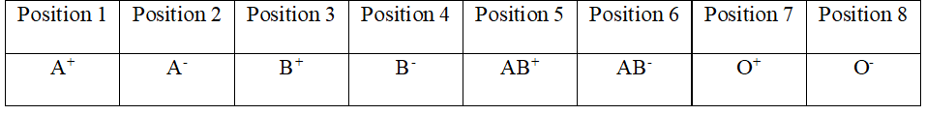

Fig. 5: Representation of an individual used in the metaheuristic implementations

Each segment from fig. 5 stores a value which is calculated using the blood proportion percentage found in the South African population. By storing each value in a separate location, this allows us to manipulate the individual in later calculations.

**3.2 Metaheuristic algorithms**

This study implemented a variety of metaheuristic algorithms to work the BAP. In total 5 metaheuristic algorithms were implemented in conjunction with the mathematical components of section 3.1. The metaheuristics include GA, PSO, DA, SOS and the GWO, prior research [7] and [8] has already researched the effects of GA and PSO in correlation to the BAP. However, no prior research was found that used the DA, SOS and GWO algorithms to solve the problem. Due to the nature of the BAP, some of the metaheuristic algorithms had to be tailored in order to accommodate the problem at hand, but still followed the overall structure pertaining to the algorithm. Using 5 algorithms also allowed for a more in-depth comparison between the results achieved per algorithm, thus allowing for a more comprehensive outcome with regards to the more superior algorithm for the BAP. The following section will explore each algorithm and different components which embody its implementation.

**3.2.1 Genetic Algorithm**

The GA implementation employs the use of populations consisting of individuals along with genetic operators such as selection, recombination and mutation [34] which was introduced by Koza in 1994 [35]. The genetic operators create diversity in a population in order to find the best possible solution to meet the demand for the day. This diversity also tries to eliminate premature convergence. A study conducted by [36] classified the GA process into 5 major components, namely: fitness function, population, selection, crossover and mutation. These 5 components were also incorporated in this study of the BAP. The structure of the individual (fig. 5) makes it possible to implement the genetic operators.

1. **Selection:** the process for selecting specific individuals from a population was conducted using tournament selection. A specified tournament size is established, from here the 2 individual with the greatest fitness values are used for the next process.
2. **Crossover:** the two individuals that were previously selected are now subjected to the crossover. Conventionally a crossover operator would select n (where n > 0) random crossover points in each individual and swap the genes accordingly. Due to the unique nature of the individual, swapping random points would result in inaccurate readings based on the blood percentages in the population. For example, a case could arise where the A+ segment (which has a relatively high percentage) could swap with a lower percentage segment such as O-. Due to this possibility, this study implemented uniform crossover which selects n random points in both individual and swaps their corresponding values. After conducting the crossover method, the algorithm is now left with 2 newly formed individuals, each of these individuals have their fitness calculated, with the fittest individual being chosen and subjected to the next step. Fig. 6 depicts the crossing over method.

Below is fig. 6 which represents the mechanics for the crossing over algorithm used within GA, to promote diversity within a population. Note that fig. 5 illustrates the labels for each position which is applied to the individuals in fig. 6.

Random crossover positions: 1, 3, 7

**Original Individual 1**

|  |  |  |  |  |  |  |  |
| --- | --- | --- | --- | --- | --- | --- | --- |
| 48 | 8 | 18 | 3 | 5 | 2 | 59 | 11 |

**Original Individual 2**

|  |  |  |  |  |  |  |  |
| --- | --- | --- | --- | --- | --- | --- | --- |
| 57 | 6 | 22 | 2 | 6 | 2 | 47 | 8 |

After crossing over

**Offspring 1**

|  |  |  |  |  |  |  |  |
| --- | --- | --- | --- | --- | --- | --- | --- |
| 57 | 8 | 22 | 3 | 5 | 2 | 47 | 11 |

**Offspring 2**

|  |  |  |  |  |  |  |  |
| --- | --- | --- | --- | --- | --- | --- | --- |
| 48 | 6 | 18 | 2 | 6 | 2 | 59 | 8 |

Fig. 6: Depicts the crossing over effect between 2 individuals and the results obtained

1. **Mutation:** mutation alters part of the individual to obtain a newer individual. This study used point mutation, the process randomly selects n number of points in the individual, and recalculates the value at that position, the recalculation process will only occur if that value in the supply individual does not equal to the value in the demand individual. For example, if position 5 would be selected, the algorithm would then generate a new value for supply by initial random amount, and multiplying it by 39% (proportion of the blood type in South Africa).

Below is fig.7 which depicts the effect of mutation on an individual. Note that fig. 5 illustrates the labels for each position which is applied to the individuals in fig. 7.

Mutation position: 3, 4

**Original Individual 1**

|  |  |  |  |  |  |  |  |
| --- | --- | --- | --- | --- | --- | --- | --- |
| 48 | 8 | 18 | 3 | 5 | 2 | 59 | 11 |

After mutation process

**Mutated Individual 1**

|  |  |  |  |  |  |  |  |
| --- | --- | --- | --- | --- | --- | --- | --- |
| 48 | 8 | 20 | 5 | 5 | 2 | 59 | 11 |

Fig. 7 illustrates the mutation process of an individual and the result obtained

Once these steps have been completed, the individual is then placed into a new population (regeneration process), with the cycle continuing until the maximum generation size is met, or a solution is found for the day. Below is algorithm 2 which illustrates the GA algorithm that was implemented in this study of the BAP.

**Algorithm 2: Genetic Algorithm**

1. =

2.

3. **Begin**

4. **For** i = 0 : i < n  5. Generate initial population

6. **End For**

7. **While** stopping criteria is false

8. Implement selection

9. Implement crossover as depicted in fig. 6

10. Implement mutation as depicted in fig. 7

11. Evaluate individual using its fitness function

12. Generate new population

13. **End** While

14. **Return** best individual

15. **End**

**3.2.2. Particle Swarm Optimization**

The Particle Swarm Optimization (PSO) is a population based metaheuristic which utilises a swarm of particles to perform is optimization process [7]. The PSO algorithm mimics behavioural patterns from animal groups that don’t have a specific leader, such as a flock of birds [37]. The algorithm begins by randomly distributing particles in a solution space and then begins its iterative process to try and locate the best solution. The optimization process relies on communication between particles in order to establish movement of the particles within the search space. The particles utilise both the experience of itself, as well as reachable neighbouring particles to guide the searching process. Given an n-dimensional space, each is characterized by a position vector Xi = (Xi1 . . . Xin) as well as a velocity vector Vi = (Vi1 . . . Vin). Both Xi and Vi make use of the following equations to iteratively update themselves.

Let $Pi$: Represents the best personal best position $Pg$: Represents the global best position $r1, r2$: Represents random values between [0, 1] $c1, c2$: Represents scaling parameters. $ω$: Represents the inertia weight $t$: Represents the iteration index

$V_{i}\left(t+1\right)= ω V_{i}\left(t\right)+c_{1}r_{1}\left(P_{i}-X_{i}\right)+c_{2}r_{2}\left(P_{g}-X_{i}\right)$ (6)

$X_{i}\left(t+1\right)=X\left(t\right)+V_{i}(t+1)$ (7)

A further look at the parameters in correlation with equations (6) and (7) reveal that $c1$ and $c2$ exert random forces in the direction of both $Pi$ and $Pg$, whilst the $ω$ value aids in regulating the velocity which in turn helps to balance global and local searches. In this paper the PSO system was customized in order to conform to the BAP. For example, considering the PSO particles and particle positions;the study conducted by [7] used a string representation (using letters corresponding to blood types) for the daily demand and supply, and transformed the string into values to represent certain components in equations (6) and (7). This current study opts out of a string representation, instead using the individual representation in fig. 3, it is possible to sum each segment to obtain a value which can relate to either $Xi$, $Pi$ and $Pg$.

**Algorithm 3: Particle swarm optimization**

1: $s:$ Swarm size 2: $d:problem dimension$

3: ${ V}_{min}$, $V_{max}$: Velocity range

4: ${ X}_{min}$, $X_{max}$: Search range

5: **Begin** 6: Initialize position and velocity for all particles in problem space

7: **While** stopping criteria is false 8: Compute inertia weight

9: **For** s size

10: **For** d size

11: Update velocity using eq. 6 and check boundary using

12: Update position using eq. 7 and check if boundary is valid.

13: Compute f($X_{i}$)

14: **End** d

15: **If $f(X_{i})$** < $f(pbest)$

16: **Then $pbest$** = $X_{i}$

17:

18: **If $f(X_{i})$** < $f(gbest)$

19: **Then $gbest$** = $X_{i}$

20: $f(X_{i})$ = $f(gbest)$

21:

22: **End** s

23: **End while**

24: Return best particle found and best fitness

25: **End Algorithm**

**3.2.3. Duellist Algorithm**

The Duellist Algorithm (DA) is based on the GA approach, which was inspired by human fighting and the ability of learning [20]. With the DA approach, all the individuals within a population are referred to as duellist, with the aspect of fighting to determine champions, winners and losers within the population. Unlike the GA approach which produce blind solutions (blind solutions relate to individuals being produced that may not be a better solution), the DA subjects’ loser individuals to learn from the winner which tries to minimize the blind effect. A winner between two individuals is based on the physical nature of an individual (fitness value) as well as a luck coefficient (LC), which is a randomly generated value. The DA implements several steps before conducting a duel between 2 individuals.

1. **Pre-Qualification:** if the duellist is below above a set fitness level, then the duellist is not selected to duel. This reduces computational time as duellists that are deemed as unfit will automatically be rejected due to the fact that they won’t be able to attain a positive outcome when duelling with another individual.
2. **Board of champions:** the board of champions aims at keeping the best duellist in the competition. The purpose of the champion is to train newer duellist to compete against each other. If the newer duellist has a better fitness than the original champion, then the duellist swaps positions with the champion.
3. **Duelling schedule:** the schedule between 2 duellists is set randomly, with each duellist using their fighting potential as well as LC to determine a winner. Conventionally, the higher the fighting potential and LC coefficient results in an individual having a greater chance of becoming a winner. In accordance to the BAP, the best solution is considered to be the individual with the lowest fitness value, therefore to adapt the DA in conjunction with the BAP, the inverse function of the randomly generated LC value is added to the fitness using the following equations and algorithm.

Algorithm 2

1. , , 2. 3 -1 4.  -1 5. 6. **If** ( ≤ Then 7. 8. $Winner = DuelistA$ 9. $Loser = Duelist$ 10. 11. **Else** 12. $Winner = DuelistB$ 13. $Loser = DuelistA$ 14. **End**

Algorithm 2 illustrates the process of establishing a winner and loser when conducting a duel between two individuals. Each duellist utilizes a luck coefficient which aids them during a duel.

1. **Duellist improvement:** after conducting the duel, the duellists are categorized either as a winner, loser or champion. The loser and winner are then treated to a form of learning in order to improve themselves. The loser learns from the winner, whilst the winner trains himself by randomly regenerating values for each segment only if that segment does not match the demand for a day, in hopes that the new result is better than the previous value. Since the demand and supply for a day follow the same individual representation, if the segment in the winner or loser individual matches the demand segment, then the segment does not change.

**Algorithm 3: Duellist Algorithm**

1.**Input**: $n:Amount of duellists$ 2 . $C$ = $Champion$

3.

4: **Begin** 5: **For**

6. Register duellists in tournament

7. **End For**

8**.** Determine

9.

10. **While** stopping criteria is false

11. Duel between duellist A and B

12. Determine and

13. trains

14. learns from

15. Eliminate duellist with worst fitness

16.

17. **If** (fitness () < fitness ())

18. =

19.

20. **End While**

21.

22. **Return**

23.

24. **End Algorithm**

**3.2.4. Symbiotic Organism Search**

The Symbiotic organism search (SOS) algorithm simulates the interactive behaviour of organisms within nature [38]. A notable advantage of the SOS algorithm is that it does not require any specific parameter tuning [39]. The search is broken into 3 main categories namely Mutualism, Commensalism and Parasitism, each of these phases alters an individual(s) within a population attempting to obtain a better solution than its original representation. Unlike the GA algorithm which procreates individuals, the SOS tries to adapt individuals through a series of phases.

1. **Mutualism**: Organisms interact with each other in a way that benefits both parties. In other words, the individuals do not experience any form of hazardous behaviour which could threaten an individual’s integrity. Eq. 8, 9 and 10 convey the act of mutualism between 2 individuals.

Let $Xi$ and $Xj$ represent 2 random individuals within a population, and MV represent the Mutual Vector.

new = + ∙ (best – ∙ ) (8)

jnew = j + ∙ (best – ∙ ) (9)

Where:

$MV$ = $(X_{i}+X_{j})$/ 2 (10)

The value obtained from (best – ) tries to increase survival in the population, with all improved individuals replacing the original individuals.

1. **Commensalism**: Organisms interact with each other in a way that results in one organism benefit without harming or altering the other organism. Selection of two organisms is done randomly from the population, and have their fitness values evaluated, the fitter individual is labelled as $X_{i}$ and the inferior individual is labelled as $X_{j}$.

$X_{inew}= X_{i}+rand \left(-1, 1\right). (X_{best}- X_{j})$ (11)

$X_{i}$ benefits from $X_{j}$ by means of $(X_{best}- X_{j})$ (12)

1. **Parasitism**: Organisms interact with each other in a way that benefits one organism (parasite) whilst harming the other organism (host). To evaluate a form of parasitism for the BAP, 2 individuals form a population are randomly selected, with each of its fitness values evaluated similar to the commensalism phase. Following the evaluation, the fitter individual is labelled as the parasite, and the inferior as the host. The parasite then swaps segments of its representation with the host only if the value (from the host) improves its original solution. The following algorithm illustrates the parasitism procedure.

**Algorithm 2: Symbiotic organism search**

1.

2. =

3.**Begin**

4. **Initialize:** Generate initial ecosystem of size n

5.

6.**While** stopping criteria is false

7.

8. Calculate fitness of each individual

9. = individual with lowest fitness 10. **End For**

11. //Implement biological interactions

12. Mutualism phase

13. Commensalism phase

14. Parasitism phase

15.

16. **If** (fitness (Par) < fitness ())

17. =

18.

18. **End While**

19.

20. **Return $X_{best}$**

21**.**

22.**End**

**3.2.5. Grey Wolf Optimizer**

The GWO was inspired from the canine family, with wolves being considered as apex predators (top of the food chain) [40]. The algorithm is moulded around a pack of wolves (the pack ranging between 5- 12 wolves), with each pack containing 3 key members the first, second and third also referred to as the alpha (α), beta (β) and delta (δ) respectively. Each of these wolves have their own tasks within the pack, for example the α is tasked with leading the pack, β wolf aids the α in decision making and is second in command, with δ wolves having to submit to α and β wolves. The lowest ranking wolves are referred to as omega wolves, which are considered the scapegoats of the pack. The GWO is defined as a predatory space of artificial wolves contained in a $N×D$ where N is the number of wolves and D is the amount of variables of the BAP. The $i^{th}$ position of a wolf is represented by $Xi = (X_{i1}, X_{i2}, …, X_{iD})$ with $X_{iD}$ is the dth variable value of the ith artificial wolf. Each value for $X$ is represented by the sum of the supply for the day, with the summed demand value representing the prey. According to [41] the hunting patterns of grey wolves follow a certain pattern.

* Tracking, chasing and moving towards the prey.
* Encircling, and harassing the prey until it stops moving
* Move forward to attack the prey.

Using this information, the GWO can be broken into individual components and mathematically modelled.

1. **Wolf pack hierarchy:** the fittest individual within the pack will be deemed as the α wolf, likewise the second and third fittest individual will be the $β$ and $δ$ wolf respectively, whilst the remaining wolves will be deemed as the $ω$. The GWO algorithm utilises this hierarchy in order to conduct the optimization process.
2. **Encircling the prey:** as mentioned previously, wolves encircle their prey during a hunt. The following equations are proposed for calculating the encircling behaviour.

Let $A$ and $C$ represent coefficient vectors.

$\vec{C}$ = 2 . $\vec{r2}$ (13)

$\vec{A}$ = 2 $\vec{a}$. $\vec{ r1}$. $\vec{a}$ (14)

Where $\vec{a}$ is linearly decreased over a set number of iterations from 2 to 0. Whilst $\vec{ r1}$, $\vec{r2 }$ represent random vectors between 0 and 1

= | . p (t) – $\vec{X}$ (t) | (15)

$\vec{X}$ (t+1) = p(t) – $\vec{A}$. $\vec{D}$ (16)

Where t indicates the iteration, p is the position vector of the prey and $\vec{X}$ represents the position vector of the hunter (grey wolf).

1. **Hunting:** the hunting component utilises the alpha wolf to lead the hunt, the beta and delta wolf may part-take in the hunt occasionally. It is assumed that the alpha, beta and delta wolves have better knowledge regarding the prey than the omega wolves. Due to the alpha taking the lead in the hunt, we assign the best candidate solution to the alpha wolf, and in ascending order of fitness, allocate the remaining candidate solutions to the beta, delta and omega wolves. After allocation of candidate solutions, the wolves then iteratively update their positions using the following equations.

α = | 1 . α -| (17)

β = | 2 . β - | (18)

δ = | 3 . δ - | (19)

1 = α – 1 (α) (20)

2 = β – 1 (β) (21)

3 = δ – 1 (δ) (22)

= (1 + 2 + 3) / 3 (23)

1. **Exploitation** **(Attacking process):** by decreasing the value of $\vec{a}$ over a set number of iterations, this mimics the process of a wolf approaching the prey. According to eq. (14), $\vec{a}$ is a component in calculating $\vec{A}$ which in turn decreases $\vec{A}$. The values for $\vec{A}$ lies between [-1, 1] with each position of the search agent lying between this specified range, if $\vec{A}$ is less than 1, this can be deemed as the wolf moving towards from the prey.
2. **Exploration (Searching for prey):** as wolves search for prey, they tend to diverge from the pack, and then converge during an attack. The divergence pattern can be calculated using the value of $\vec{A}$ bounded between [-1, 1] this allows for global exploration to take place. Exploration is also favoured by component $\vec{C}$ which contains random values between [0, 2]. Component $\vec{C}$ allocates random weights to the prey in order to emphasize (C > 1) and deemphasize (C < 1). As mentioned previously, A is linearly decreased, by C is assigned random values to emphasize the exploration process. Component C can also be interpreted as a naturally occurring obstacles which occur during a hunt. Depending on the position of the wolf, C can randomly give the prey a weight which either makes it easier or harder for the wolf to catch the prey.
3. **General implementation:** the GWO starts with an initial random population of grey wolves (candidate solutions) which in correlation with the BAP, are represented as the supply of blood units for the day. The demand for WB units in a day is interpreted as the prey. The position of each wolf and prey equates to the sum of the values of each segment within the individual’s representation (figure 3). Using the equations stated in (13-23), each candidate solution iteratively updates their position from the prey, with the parameter $\vec{a}$ being linearly decreased from 2 to 0 over a number of iterations. Candidate solutions tend to converge towards the prey when || < 1 and diverge when || > 1. The termination criteria terminates when the max number of iterations have been reached, or the supply equates to the demand for a day. The reduced amount of search parameters of the GWO implementation is an important advantage of the algorithm [29].

**Algorithm 2: Grey wolf optimizer**

1.

2. Coefficient vectors and

3.

4. **Begin**

5. **For** length of pack size

6. Generate initial population

7. Evaluate fitness of each individual

8. **End** for

9.

10. Assign α to best individual

11. Assign β to second best individual

12. Assign δ to third best individual

13.

14. **While** stopping criteria is false

15.

16. Update search agents using equation

17. Decrement parameter

18. Update coefficients $\vec{A}$ and $\vec{C}$ using equation

19. Evaluate fitness of each search agent

20.

21. **End** inner while

22. Update α, β, δ

23. **End** outer while

24.

25.**Return** α individual

26.

27.**End**

**3.3 Data generation**

As mentioned previously, datasets were generated stochastically as real-world datasets could not be attained. As such, previous work done by [7], [8] and [28] constructed datasets using ranged percentage bounds and subsequently randomly selected a percentage between the bounds. This study also adopted the same principals and used a random number generator (RNG) in order to generate the datasets. The datasets were run over a course of 1 year (365 days) and generated values for supply and demand of WB units. The blood bank can also experience certain situations which the blood bank must deal with, for example the demand for WB units could exceed the supply or vice versa. Below is a table illustrating the demand ranges followed per dataset. The following table lists the different datasets used for testing each metaheuristic algorithm. Note that SAGV represents South African Generated Values.

**Table 7**: Representation of the datasets 1-6 used in this study of the BAP

|  |  |  |  |
| --- | --- | --- | --- |
| Dataset | Initial Blood Volume | Demand bounds (%) | Supply bounds (%) |
| 1 | 500 | 25-75 | 25-75 |
| 2 | 500 | SAGV | 25-75 |
| 3 | 500 | 75-100 | 25-50 |
| 4 | 500 | 25-50 | 75-100 |
| 5 | 5000 | 25-75 | 25-75 |
| 6 | 5000 | SAGV | 25-75 |

In accordance to table the following is more detailed explanation relating to each dataset.

**Dataset 1**

Dataset 1 was regarded as the control dataset which was used as a comparison to other datasets. Previous literatures pertaining to the BAP used similar percentage ranges and initial blood volume, therefore it seemed appropriate to evaluate the metaheuristic algorithms with these amounts.

**Dataset 2**

Apart from the different metaheuristic algorithms that were implemented to work the BAP, this studied also incorporated a unique method for generating demand based on South African statistics (refer to section). Dataset 2 represented this ideology and tries to minimize the stochastic nature when randomly generating values for WB unit demand. The SAGV illustrated in table correlate to percentage bounds mentioned in table.

**Dataset 3**

The blood bank can face a situation where the demand for WB units heavily exceeds the current supply on hand. Dataset 3 tests this scenario, and it was expected for the importation levels to increase radically in order to satisfy the demand. More importation results in a greater expense being incurred by the blood bank, therefore dataset 3 tested how well an algorithm coped with a higher demand level.

**Dataset 4**

Dataset 4 tests the opposite of dataset 3. In this scenario the blood bank faces an excess supply of WB units with minimal demand. It would be expected for the expiry levels to increase as the more stock of WB units will remain on the shelf and not be used within its lifespan. This also incurs additional expenses by the blood bank and implies that the blood bank is not utilising its WB stock efficiently.

**Dataset 5 and 6**

Dataset 5 and 6 is a replica of dataset 1 and 2 respectively. However, they differ by means of initial WB volume being 5000 units. This examines how well the blood bank handles large amounts of blood units. Due to the previous days remainder being added to the new days’ supply, the levels of WB units supply were expected to be relatively high.

**4. Experimental Results**

The previous chapter gave an overview of the mathematical model and metaheuristic algorithms used in this study of the BAP. The following chapter will offer line graphs and averages attained in association with each metaheuristic. The objective function relates to minimizing the overall importation and expiration of blood units, whilst ensuring that all blood demands are met within a day. In an ideal day the request levels would be identical to the stock on hand which is deemed as a solution. A solution being located implies that no form of importation can occur, and the chances of possible expiry are reduced. The chances of finding a solution is higher at the start of the year as stock-piling might take some time to come into effect, once a system is in the stock-piling phase then the chances of obtaining a solution largely decreases. This chapter also provides an in-depth comparison between each algorithm in order to establish which algorithm performed the best for the particular dataset.

**4.1. Experimental setup**

Each metaheuristic algorithm was implemented using the Java programming language. The datasets mentioned in table where subjected to each algorithm in order to obtain an output. Four variables were recorded namely: demand, supply, importation and expiry, an algorithm would be deemed as effective if it amasses low amounts of expiry and importation of WB units. In total, 5 metaheuristics were subjected to 6 datasets resulting in 30 outcomes, all of which were tabulated and graphed accordingly. Since the remainder of a previous day being added to the donations received by the current day it is unlikely that a solution could be found. With this in mind the results were evaluated using 3 different aspects

* Running time
* Average amounts of both importation and expiration
* Time taken before stock-piling occurred

Running time relates to the duration for an algorithm to run over a 365 day period, the smaller the running time the better the algorithm. The average amounts for both expiry and importation correlates to the objection function mentioned in section. Finally, the time taken for stock-piling to occur drastically reduces the levels of importation, and can therefore be seen as a positive effect. Stock-piling does increase the risk of possible expiry, but due to the lifespan of a WB unit being 30 days, it is unlikely for a blood unit to exceed this time frame.

**4.2. Results and Discussion**

**4.2.1 Dataset 1**

Dataset 1 posed as the control dataset as previous literatures used similar percentage bounds when generating demand and supply values. A control dataset establishes a baseline of results that can be compared against other datasets in order to attain similarities and differences. Dataset 1 used percentage bounds ranging between 25-75% for generating both demand and supply.

Table 8: Average results achieved for each metaheuristic implementation subjected to dataset 1 for each blood group measured in units.

|  |  |  |  |  |  |  |  |  |  |
| --- | --- | --- | --- | --- | --- | --- | --- | --- | --- |
| **MT** | **Variable** | **A+** | **A-** | **B+** | **B-** | **AB+** | **AB-** | **O+** | **O-** |
| **GA** | **Supply** | 40.00 | 6.25 | 15.00 | 2.50 | 3.75 | 1.25 | 48.75 | 8.75 |
|  | **Demand** | 192.81 | 88.67 | 78.67 | 35.41 | 15.27 | 6.36 | 131.83 | 87.80 |
|  | **Import** | 0.00 | 0.00 | 0.08 | 0.01 | 0.28 | 0.01 | 0.02 | 0.00 |
|  | **Expiry** | 0.00 | 0.00 | 0.00 | 0.00 | 0.00 | 0.00 | 0.00 | 0.00 |
| **PSO** | **Supply** | 162.7 | 7.25 | 61.35 | 3.26 | 16.16 | 12.90 | 47.51 | 9.94 |
|  | **Demand** | 40.51 | 6.33 | 15.19 | 2.53 | 3.80 | 1.27 | 49.37 | 8.86 |
|  | **Import** | 2.81 | 1.71 | 0.67 | 0.70 | 0.48 | 0.02 | 14.90 | 2.39 |
|  | **Expiry** | 0.00 | 0.00 | 0.00 | 0.00 | 0.00 | 0.00 | 0.00 | 0.00 |
| **DA** | **Supply** | 295.00 | 133.40 | 120.90 | 56.00 | 26.50 | 11.00 | 176.20 | 136.40 |
|  | **Demand** | 39.27 | 6.14 | 14.72 | 2.45 | 3.68 | 1.23 | 47.86 | 8.59 |
|  | **Import** | 0.45 | 0.03 | 0.17 | 0.00 | 0.25 | 0.02 | 0.35 | 0.02 |
|  | **Expiry** | 0.00 | 0.00 | 0.00 | 0.00 | 0.00 | 0.00 | 0.00 | 0.00 |
| **SOS** | **Supply** | 192.81 | 88.67 | 78.67 | 35.41 | 15.27 | 6.36 | 131.83 | 87.80 |
|  | **Demand** | 40.00 | 6.25 | 15.00 | 2.50 | 3.75 | 1.25 | 48.75 | 8.75 |
|  | **Import** | 0.00 | 0.00 | 0.08 | 0.01 | 0.28 | 0.01 | 0.02 | 0.00 |
|  | **Expiry** | 0.00 | 0.00 | 0.00 | 0.00 | 0.00 | 0.00 | 0.00 | 0.00 |
| **GWO** | **Supply** | 60.07 | 30.10 | 20.73 | 6.41 | 1.76 | 1.51 | 68.73 | 16.79 |
|  | **Demand** | 40.32 | 6.30 | 15.12 | 2.52 | 3.78 | 1.26 | 49.14 | 8.82 |
|  | **Import** | 1.36 | 0.01 | 1.07 | 0.09 | 2.02 | 0.26 | 1.14 | 0.00 |
|  | **Expiry** | 0.00 | 0.00 | 0.00 | 0.00 | 0.00 | 0.00 | 0.00 | 0.00 |

Table 9: Represents the running time per metaheuristic for dataset 1

|  |  |  |
| --- | --- | --- |
| **Metaheuristic** | **Time (Ms)** | **Time(Minutes)** |
| **GA** | 4748287 | 79.14 |
| **PSO** | 504291 | 8.40 |
| **DA** | 4899566 | 81.66 |
| **SOS** | 4776186 | 79.60 |
| **GWO** | 4752407 | 79.21 |

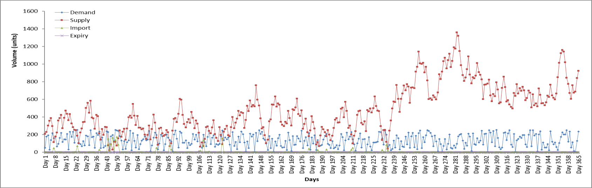

Fig. 8: Represents a line graph over a period of 365 days for the GA implementation of dataset 1

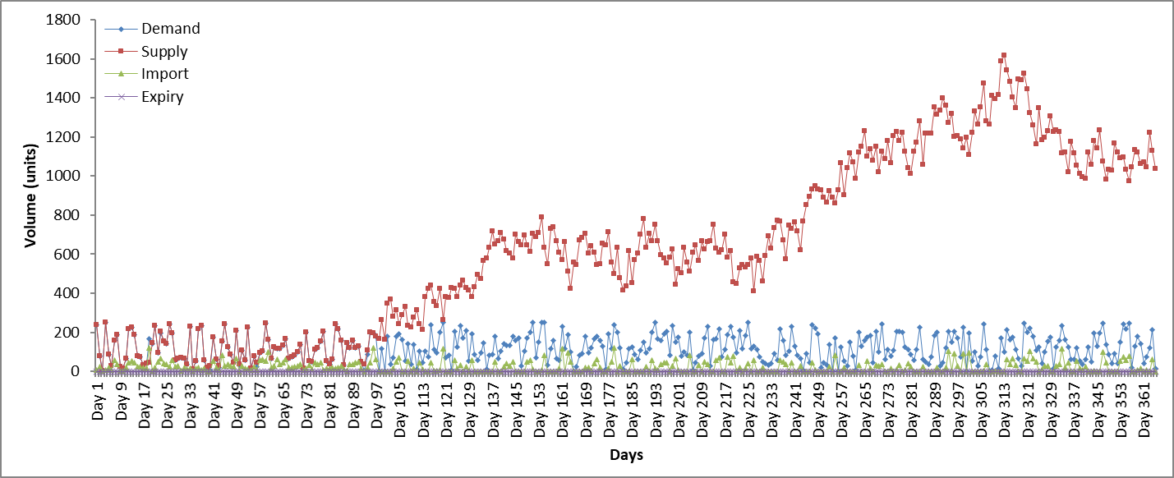

Fig. 9: Represents a line graph over a period of 365 days for the PSO implementation of dataset 1

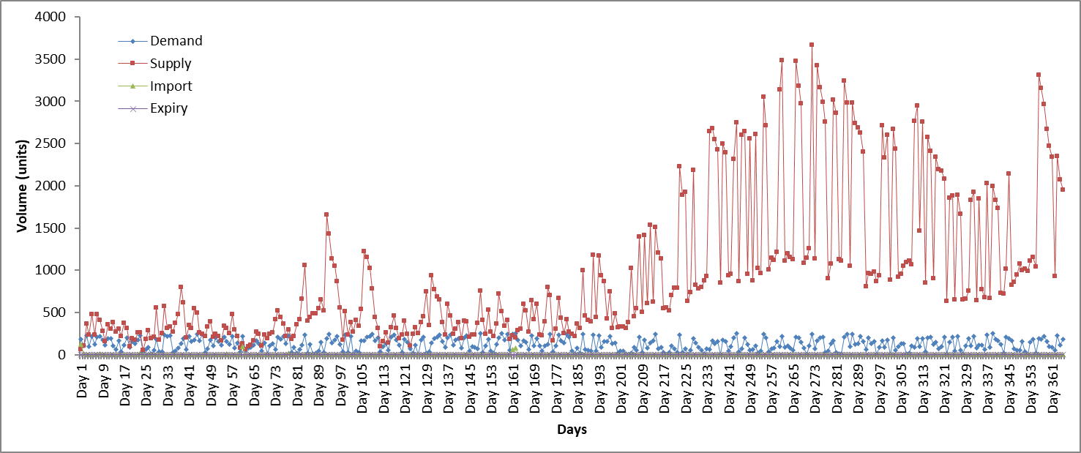

Fig. 10: Represents a line graph over a period of 365 days for the DA implementation of dataset 1

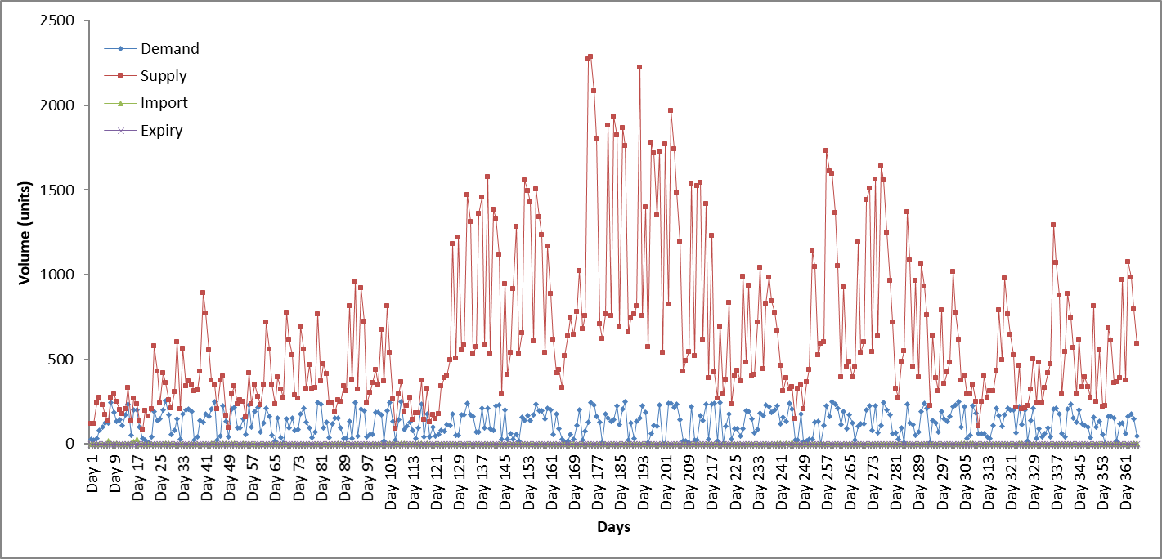

Fig. 11: Represents a line graph over a period of 365 days for the SOS implementation of dataset 1

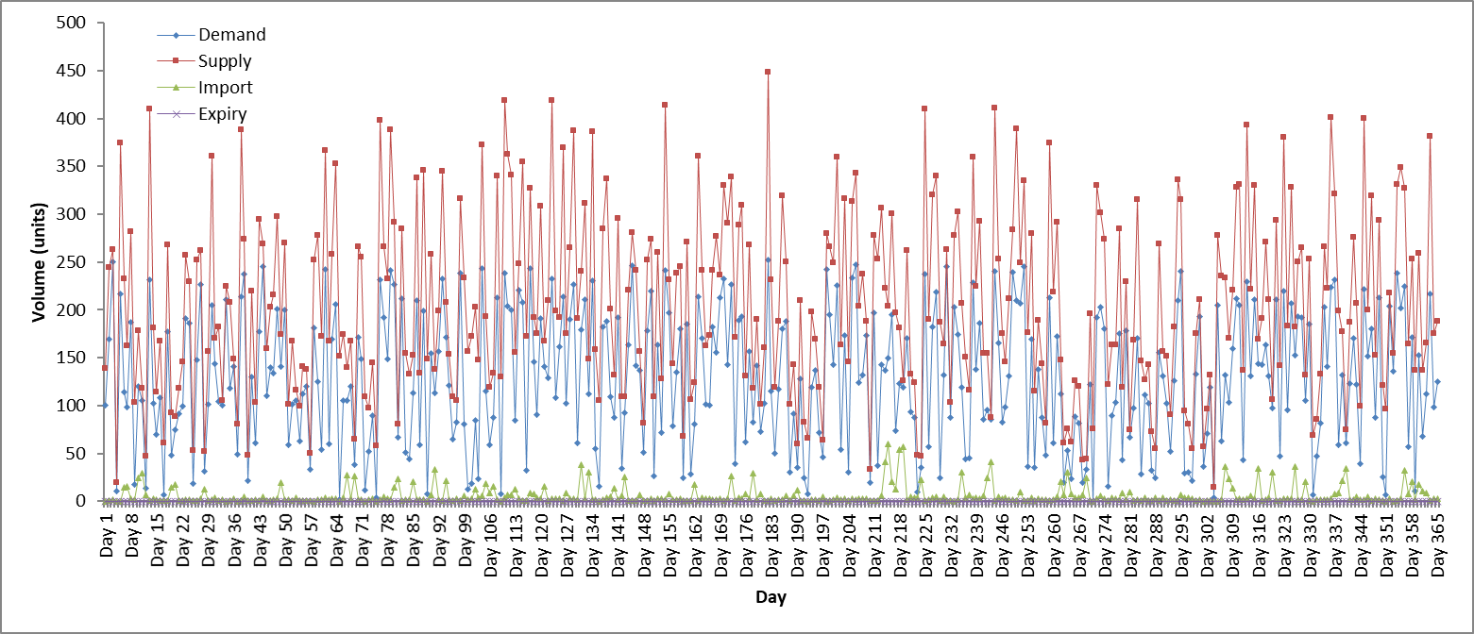

Fig.12: Represents a line graph over a period of 365 days for the GWO implementation of dataset 1

**Discussion for dataset 1**

Fig. 8-12 represent line graphs obtained when each metaheuristic was subjected to dataset 1. Table illustrates the running times obtained per algorithm, most algorithms achieved a running time exceeding 70 minutes, however the PSO algorithm was much quicker achieving a duration time of 8.4 minutes. No algorithms experienced any form of expiry throughout the time frame.

* The GA algorithm experienced stock-piling around day 233, before then imports occurred on sporadic days mainly for blood types B+ and AB+. Blood types A+, A- and O- experienced no form of importation within the time frame. Around days 22, 85 and 127, the algorithm experienced very brief periods of stock-piling however these lasted for periods of approximately 20 days.
* PSO experienced stock piling at a very early period (around day 90). However, low levels of importation still occurred throughout the 365 day period, with importation mainly being accredited to blood types A+ and O-. This implies that the algorithm struggles to stock-pile for these blood types in particular.
* DA experienced a brief period of stock-piling around day 73, however this only occurred for approximately 30 days. A steady rate of stock-piling only started to occur after day 180, this resulted in large amounts of WB units supply and no form of importation for any blood types.
* The SOS algorithm experienced stock-piling around day 120, with very little importation levels throughout the time frame.
* GWO produced random results throughout its time frame with no distinguishable pattern. The GWO algorithm never experienced stock-piling and had minimal importation amounts occurring frequently. The results also show that O- blood was the only blood type not to experience importation, whilst blood types A-, B- and AB- had relatively small importation averages. This implies that the algorithm is able to manage blood types that are rarer (scarce in society) more efficiently,

After assessing each algorithm, it is definitive that the SOS algorithm outperforms the other algorithms when subjected to dataset 1. Even though the SOS algorithm performed much slower (in terms of computational time) to the PSO system, it incurred the lowest averages relating to importation, and was the second fastest to experience stock-piling.

**4.2.2 Dataset 2**

Dataset 2 incorporates South African generated values in order to generate percentage bounds for each month (refer to table). Due to certain months having lower percentage bounds, the overall averages attained for both demand and supply are lower as compared dataset 1. A more in-depth comparison will discussed in section

Table 10: Average results achieved for each metaheuristic implementation subjected to dataset 2 for each blood group measured in units.

|  |  |  |  |  |  |  |  |  |  |
| --- | --- | --- | --- | --- | --- | --- | --- | --- | --- |
| **MT** | **Variable** | **A+** | **A-** | **B+** | **B-** | **AB+** | **AB-** | **O+** | **O-** |
| **GA** | **Supply** | 157.87 | 26.43 | 59.48 | 20.51 | 13.08 | 9.35 | 192.73 | 39.42 |
|  | **Demand** | 19.67 | 3.07 | 7.38 | 1.23 | 1.84 | 0.61 | 23.98 | 4.30 |
|  | **Import** | 0.07 | 0.00 | 0.01 | 0.00 | 0.01 | 0.00 | 0.09 | 0.00 |
|  | **Expiry** | 0.00 | 0.00 | 0.00 | 0.00 | 0.00 | 0.00 | 0.00 | 0.00 |
| **PSO** | **Supply** | 278.14 | 3.57 | 101.07 | 1.79 | 24.84 | 10.51 | 25.50 | 4.98 |
|  | **Demand** | 19.28 | 3.01 | 7.23 | 1.20 | 1.81 | 0.60 | 23.50 | 4.22 |
|  | **Import** | 1.29 | 0.71 | 0.09 | 0.31 | 0.23 | 0.04 | 5.60 | 0.96 |
|  | **Expiry** | 0.00 | 0.00 | 0.00 | 0.00 | 0.00 | 0.00 | 0.00 | 0.00 |
| **DA** | **Supply** | 27.40 | 8.53 | 10.29 | 3.27 | 1.90 | 1.07 | 35.90 | 9.99 |
|  | **Demand** | 20.01 | 3.13 | 7.51 | 1.25 | 1.88 | 0.63 | 24.39 | 4.38 |
|  | **Import** | 2.61 | 0.09 | 0.81 | 0.03 | 0.60 | 0.12 | 1.38 | 0.13 |
|  | **Expiry** | 0.00 | 0.00 | 0.00 | 0.00 | 0.00 | 0.00 | 0.00 | 0.00 |
| **SOS** | **Supply** | 222.87 | 43.48 | 76.14 | 24.06 | 19.19 | 9.34 | 294.67 | 52.15 |
|  | **Demand** | 19.08 | 2.98 | 7.15 | 1.19 | 1.79 | 0.60 | 23.25 | 4.17 |
|  | **Import** | 0.11 | 0.00 | 0.03 | 0.00 | 0.01 | 0.00 | 0.08 | 0.00 |
|  | **Expiry** | 0.00 | 0.00 | 0.00 | 0.00 | 0.00 | 0.00 | 0.00 | 0.00 |
| **GWO** | **Supply** | 29.48 | 15.30 | 10.10 | 3.90 | 0.85 | 0.86 | 35.87 | 7.73 |
|  | **Demand** | 19.96 | 3.12 | 7.48 | 1.25 | 1.87 | 0.62 | 24.33 | 4.37 |
|  | **Import** | 0.72 | 0.01 | 0.52 | 0.05 | 1.02 | 0.17 | 0.57 | 0.00 |
|  | **Expiry** | 0.00 | 0.00 | 0.00 | 0.00 | 0.00 | 0.00 | 0.00 | 0.00 |

Table 11: Represents the running time per metaheuristic for dataset 2

|  |  |  |
| --- | --- | --- |
| Metaheuristic | Time (Ms) | Time(Minutes) |
| GA | 3983352 | 66.38 |
| PSO | 561452 | 9.35 |
| DA | 4113223 | 68.55 |
| SOS | 4665054 | 77.75 |
| GWO | 4525144 | 75.41 |

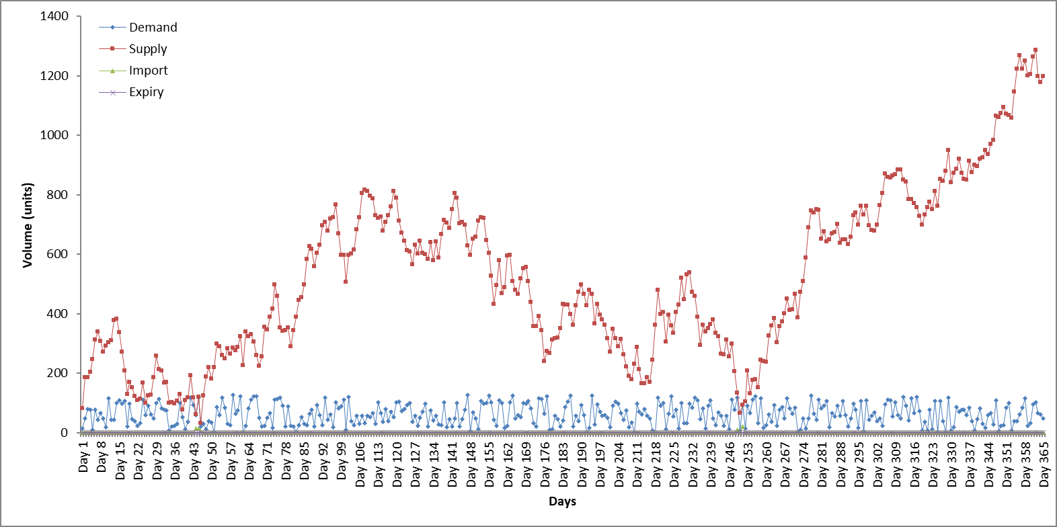

Fig. 13: Represents a line graph over a period of 365 days for the GA implementation of dataset 2

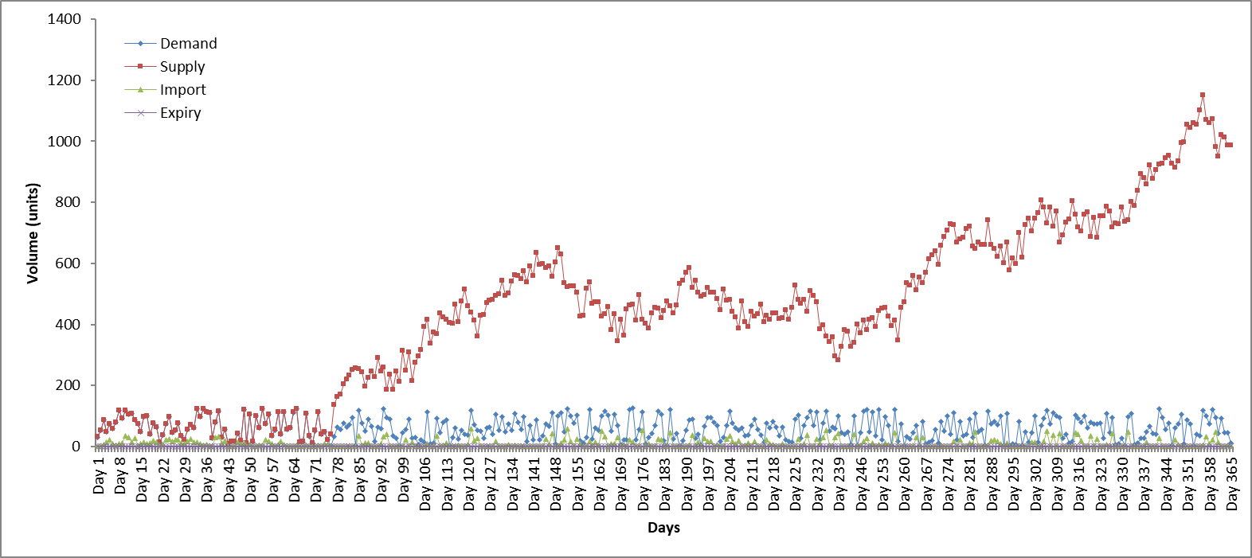

Fig. 14: Represents a line graph over a period of 365 days for the PSO implementation of dataset 2

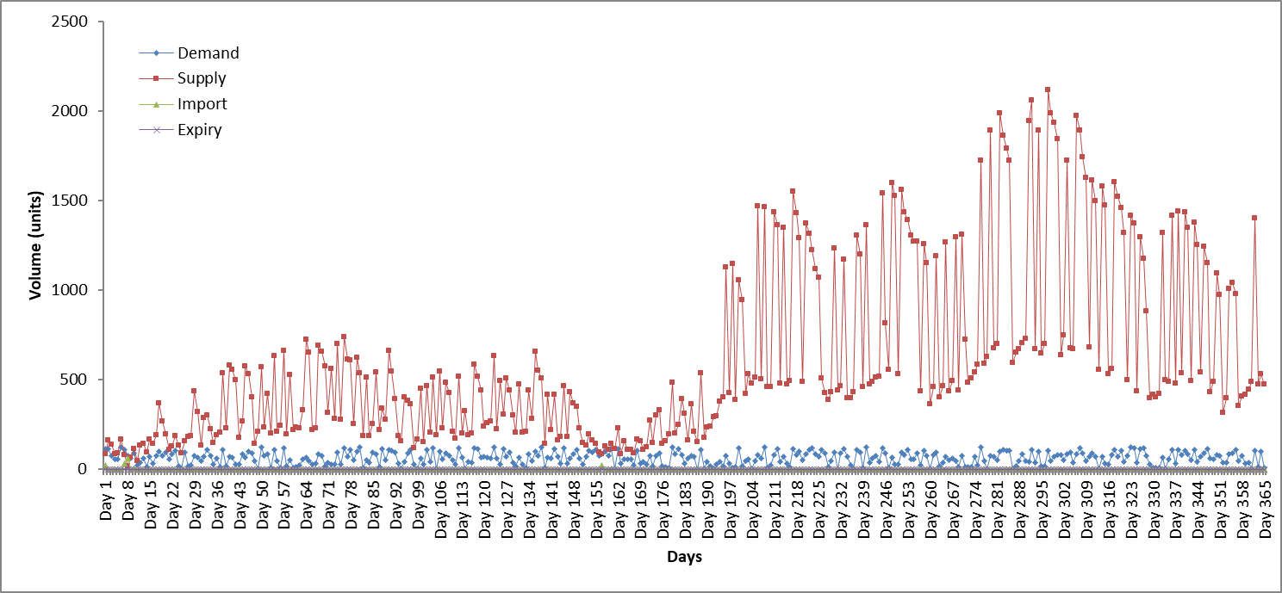

Fig.15: Represents a line graph over a period of 365 days for the DA implementation of dataset 2

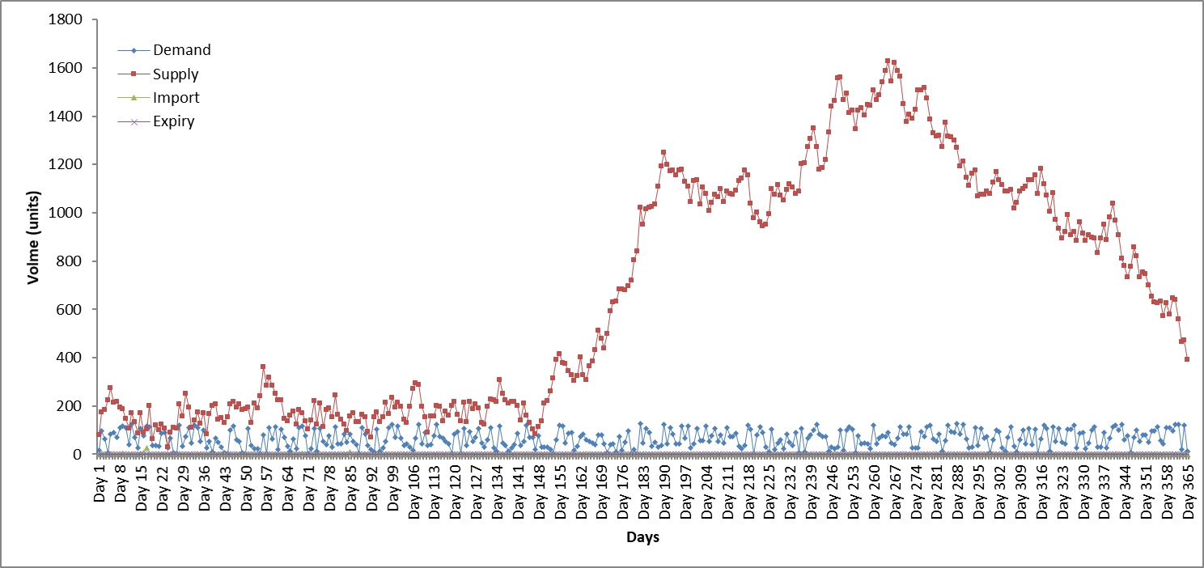

Fig. 16: Represents a line graph over a period of 365 days for the SOS implementation of dataset 2

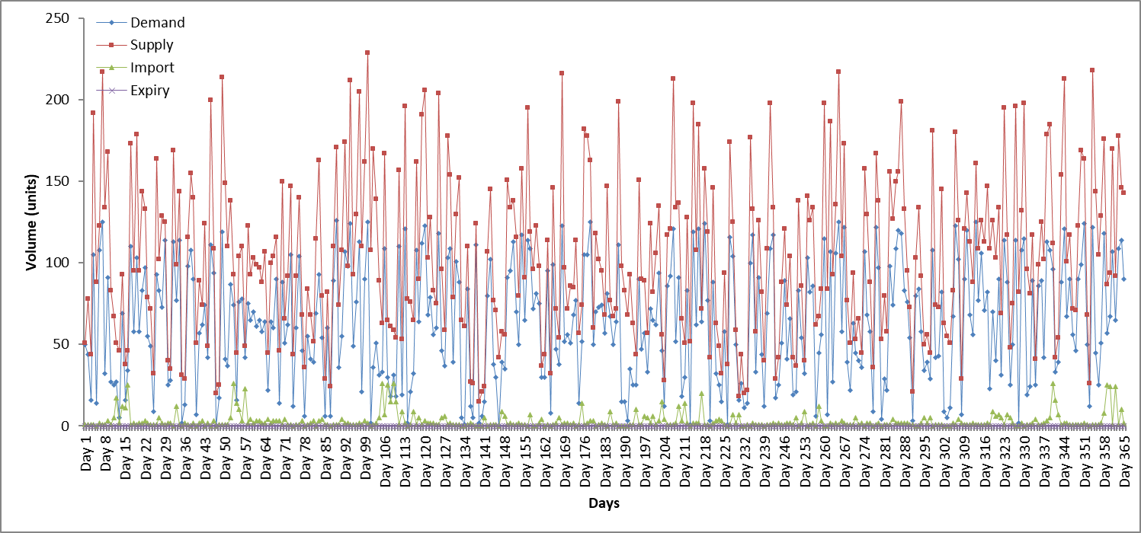

Fig. 17: Represents a line graph over a period of 365 days for the GWO implementation of dataset 2

**Discussion about dataset 2**

Fig. 13-17 represent line graphs obtained when each metaheuristic was subjected to dataset 2, whilst table depicts the running times obtained per algorithm**.** In comparison to the running times achieved from dataset 1, all the algorithms except the PSO achieved smaller computational times. A noteworthy aspect relates to the average demands attained per blood type. Due to the generation of demand value in dataset 2 the average levels have decreased for majority of the algorithms. Similar to dataset 1, no form of expiry occurred for any of the algorithms.

* The GA algorithm experienced stock-piling at a very early period (around day 43), with the largest importation amounts occurring for blood types A+ and O+, implying that the algorithm cannot attain adequate blood supplies for two relatively abundant blood types.
* Similar to the results obtained from the GA algorithm, the PSO heavily imports for blood types A+ and O+. In addition, the PSO took a larger computational time in comparison to dataset 1, and only achieved stock-piling around day 77.
* The line graph depicted in fig is similar to the pattern obtained from dataset 1 results, in that the supply for blood heavily fluctuates between days. Even though the DA algorithm achieved stock-piling at a very early day (day 25), the accumulation of small importation levels for the less common blood types occurred throughout the time frame.
* The SOS algorithm achieved stock-piling around day 148 which in prospective to the other algorithms can be deemed as considerably slow. However, similar to dataset 1 the SOS algorithm achieved very low importation levels.
* In dataset 1, the GWO algorithm did not achieve stock-piling, and there was no difference in dataset 2. The average importation levels for GWO was relatively low, with importation occurring throughout the time frame.

Due to the algorithm experiencing stock-piling at an early period coupled with its low importation levels for the certain blood types, the GA can be deemed as the more efficient algorithm for dataset 2. Dataset 2 tried to emphasize the concept of generating data based on South African statistics, the fluctuating demand bounds directly links with the decrease in total averages attained per blood type as compared to dataset 1.

**4.2.3 Dataset 3**

Dataset 3 serves to examine how well each metaheuristic algorithm performed when subjected to an instance of the demand exceeding the supply. As expected the average levels of demand per blood type exceeded the average supply. This is a scenario which was identified as an expense to the blood bank due to additional WB units needing to be imported in order to satisfy the demand in a day.

**Table 12**: Average results achieved for each metaheuristic implementation subjected to dataset 3 for each blood group measured in units.

|  |  |  |  |  |  |  |  |  |  |
| --- | --- | --- | --- | --- | --- | --- | --- | --- | --- |
| **MT** | **Variable** | **A+** | **A-** | **B+** | **B-** | **AB+** | **AB-** | **O+** | **O-** |
| **GA** | **Supply** | 25.72 | 4.12 | 9.65 | 1.67 | 2.32 | 0.90 | 31.31 | 5.68 |
|  | **Demand** | 38.69 | 6.05 | 14.51 | 2.42 | 3.63 | 1.21 | 47.16 | 8.46 |
|  | **Import** | 18.96 | 2.94 | 7.11 | 1.18 | 1.82 | 0.61 | 23.11 | 4.12 |
|  | **Expiry** | 0.00 | 0.00 | 0.00 | 0.00 | 0.00 | 0.00 | 0.00 | 0.00 |
| **PSO** | **Supply** | 33.26 | 8.13 | 16.11 | 5.07 | 0.97 | 2.54 | 47.98 | 12.35 |
|  | **Demand** | 40.54 | 6.33 | 15.20 | 2.53 | 3.80 | 1.27 | 49.41 | 8.87 |
|  | **Import** | 7.69 | 0.40 | 1.19 | 0.08 | 2.86 | 0.24 | 3.05 | 0.13 |
|  | **Expiry** | 0.00 | 0.00 | 0.00 | 0.00 | 0.00 | 0.00 | 0.00 | 0.00 |
| **DA** | **Supply** | 41.47 | 6.48 | 15.55 | 2.59 | 3.89 | 1.30 | 50.55 | 9.07 |
|  | **Demand** | 48.83 | 16.24 | 17.84 | 6.15 | 2.19 | 1.73 | 56.38 | 18.24 |
|  | **Import** | 7.07 | 0.68 | 2.85 | 0.28 | 2.06 | 0.26 | 8.13 | 0.91 |
|  | **Expiry** | 0.00 | 0.00 | 0.00 | 0.00 | 0.00 | 0.00 | 0.00 | 0.00 |
| **SOS** | **Supply** | 68.90 | 28.51 | 27.04 | 11.63 | 3.08 | 2.40 | 72.98 | 30.71 |
|  | **Demand** | 37.16 | 5.81 | 13.93 | 2.32 | 3.48 | 1.16 | 45.29 | 8.13 |
|  | **Import** | 1.20 | 0.01 | 0.39 | 0.01 | 1.51 | 0.10 | 0.68 | 0.00 |
|  | **Expiry** | 0.00 | 0.00 | 0.00 | 0.00 | 0.00 | 0.00 | 0.00 | 0.00 |
| **GWO** | **Supply** | 16.14 | 3.20 | 6.25 | 0.38 | 0.85 | 0.05 | 19.01 | 4.46 |
|  | **Demand** | 21.06 | 3.29 | 7.90 | 1.32 | 1.97 | 0.66 | 25.66 | 4.61 |
|  | **Import** | 6.43 | 1.14 | 2.34 | 1.10 | 1.15 | 0.63 | 8.10 | 0.97 |
|  | **Expiry** | 0.00 | 0.00 | 0.00 | 0.00 | 0.00 | 0.00 | 0.00 | 0.00 |

**Table 13**: Running time per metaheuristic for dataset 3

|  |  |  |
| --- | --- | --- |
| Metaheuristic | Time (Ms) | Time(Minutes) |
| GA | 3872251 | 64.54 |
| PSO | 494639 | 8.24 |
| DA | 4203022 | 70.05 |
| SOS | 4765186 | 79.42 |
| GWO | 4623043 | 77.05 |

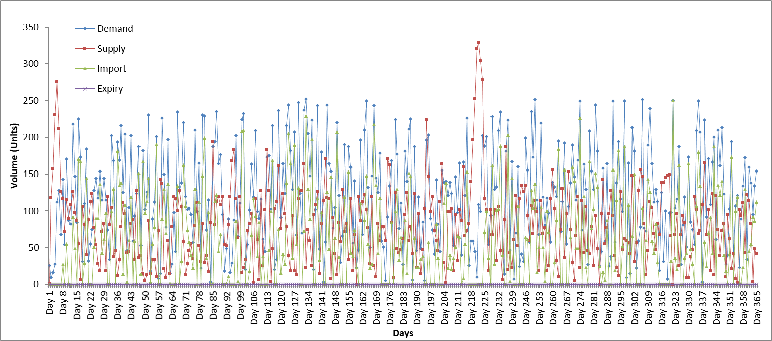

Fig. 18: Represents a line graph over a period of 365 days for the GA implementation of dataset 3

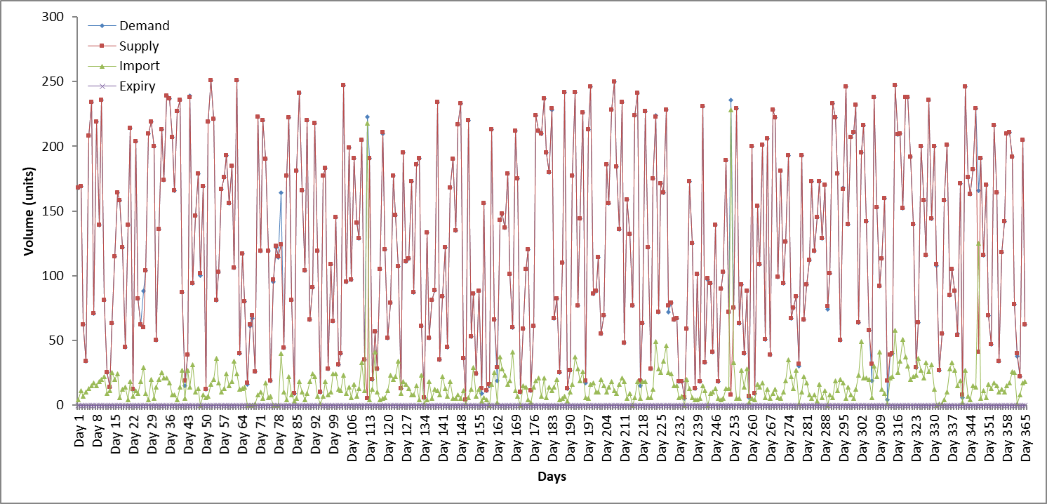

Fig. 19: Represents a line graph over a period of 365 days for the PSO implementation of dataset 3

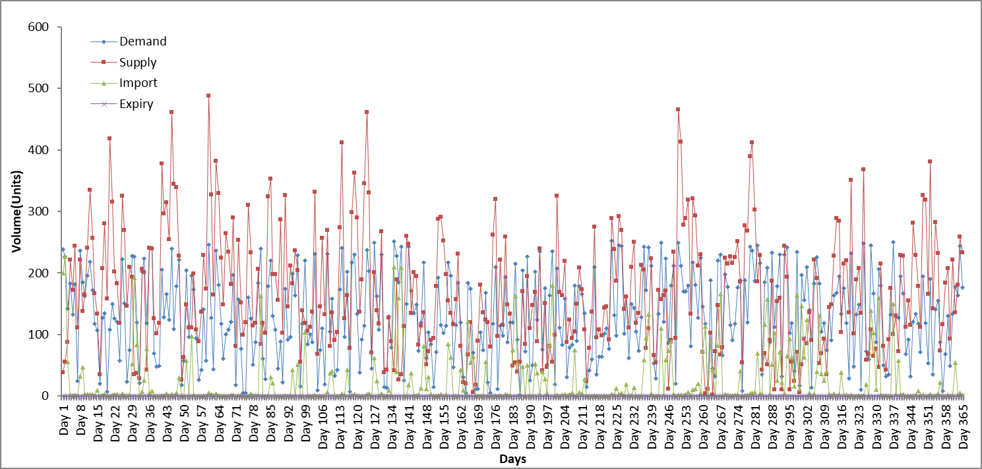

Fig. 20: Represents a line graph over a period of 365 days for the DA implementation of dataset 3

Fig. 20: Represents a line graph over a period of 365 days for the DA implementation of dataset 3

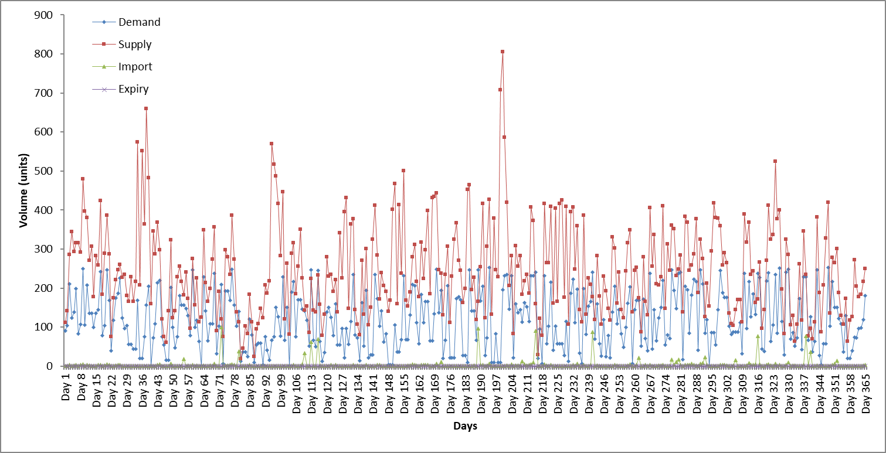

Fig. 21: Represents a line graph over a period of 365 days for the SOS implementation of dataset 3

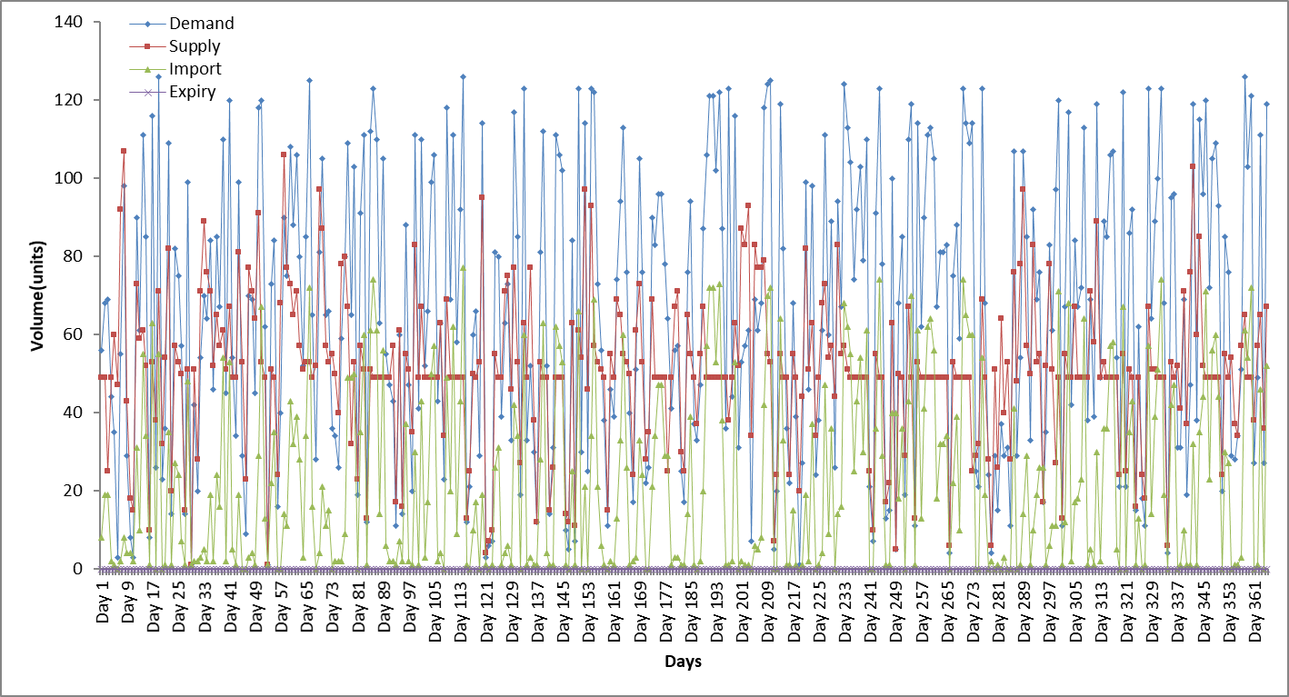

Fig. 22: Represents a line graph over a period of 365 days for the GWO implementation of dataset

Dataset 3 tests how well a blood bank copes when the demand exceeds the supply on hand for any given day. None of the algorithms achieved stock-piling, and achieved drastic increases in regard to the average importation levels for each blood type. Fig. 18-22 represent line graphs obtained when each metaheuristic was subjected to dataset 2, whilst table depicts the running times obtained per algorithm**.** In comparison to the running times achieved from dataset 1, all algorithms experienced a decrease in total time taken for the algorithm to terminate. There are no significant aspects to analyse per algorithm as no stock-piling or expiry occurred. Overall the SOS system delivered far fewer importation levels per blood type and can be deemed as the best algorithm to work dataset 3.

**4.2.3 Dataset 4**

Dataset 4 tests the opposite of dataset 3 whereas the supply exceeds the demand within the time frame. The level of expiry was expected to increase, however due to the lifespan of a WB unit being 30 days the level of expiry across any algorithm remained at 0. If expiry did occur, it would have implied that the metaheuristic algorithm could not utilise resources efficiently, and in the real-world blood banks would be expected to dispose of these unusable WB units in a proper manner which incurs additional expenses.

**Table 14**: Average results achieved for each metaheuristic implementation subjected to dataset 3 for each blood group measured in units.

|  |  |  |  |  |  |  |  |  |  |
| --- | --- | --- | --- | --- | --- | --- | --- | --- | --- |
| MT | Variable | A+ | A- | B+ | B- | AB+ | AB- | O+ | O- |
| GA | Supply | 2124.89 | 335.79 | 791.17 | 152.07 | 195.07 | 66.28 | 2583.42 | 469.82 |
|  | Demand | 20.62 | 3.22 | 7.73 | 1.29 | 1.93 | 0.64 | 25.13 | 4.51 |
|  | Import | 0.00 | 0.00 | 0.00 | 0.00 | 0.00 | 0.00 | 0.00 | 0.00 |
|  | Expiry | 0.00 | 0.00 | 0.00 | 0.00 | 0.00 | 0.00 | 0.00 | 0.00 |
| PSO | Supply | 3584.50 | 6.29 | 1350.75 | 2.52 | 328.10 | 100.46 | 49.15 | 8.80 |
|  | Demand | 20.65 | 3.23 | 7.74 | 1.29 | 1.94 | 0.65 | 25.17 | 4.52 |
|  | Import | 0.00 | 0.00 | 0.00 | 0.00 | 0.00 | 0.00 | 0.00 | 0.00 |
|  | Expiry | 0.00 | 0.00 | 0.00 | 0.00 | 0.00 | 0.00 | 0.00 | 0.00 |
| DA | Supply | 1893.13 | 470.49 | 715.33 | 169.36 | 175.23 | 56.17 | 506.27 | 461.14 |
|  | Demand | 19.71 | 3.08 | 7.39 | 1.23 | 1.85 | 0.62 | 24.02 | 4.31 |
|  | Import | 0.00 | 0.00 | 0.00 | 0.00 | 0.00 | 0.00 | 0.00 | 0.00 |
|  | Expiry | 0.00 | 0.00 | 0.00 | 0.00 | 0.00 | 0.00 | 0.00 | 0.00 |
| SOS | Supply | 3419.58 | 565.67 | 1308.53 | 209.98 | 326.20 | 98.90 | 4172.27 | 746.18 |
|  | Demand | 18.84 | 2.94 | 7.07 | 1.18 | 1.77 | 0.59 | 22.96 | 4.12 |
|  | Import | 0.00 | 0.00 | 0.00 | 0.00 | 0.00 | 0.00 | 0.00 | 0.00 |
|  | Expiry | 0.00 | 0.00 | 0.00 | 0.00 | 0.00 | 0.00 | 0.00 | 0.00 |
| GWO | Supply | 3977.10 | 617.69 | 1498.53 | 257.23 | 363.27 | 118.53 | 4843.29 | 868.76 |
|  | Demand | 20.31 | 3.17 | 7.61 | 1.27 | 1.90 | 0.63 | 24.75 | 4.44 |
|  | Import | 0.00 | 0.00 | 0.00 | 0.00 | 0.00 | 0.00 | 0.00 | 0.00 |
|  | Expiry | 0.00 | 0.00 | 0.00 | 0.00 | 0.00 | 0.00 | 0.00 | 0.00 |

**Table 15**: Running time per metaheuristic for dataset 4

|  |  |  |
| --- | --- | --- |
| Metaheuristic | Time (Ms) | Time(Minutes) |
| GA | 5220157 | 87.00 |
| PSO | 500968 | 8.34 |
| DA | 5135744 | 85.60 |
| SOS | 5978164 | 99.63 |
| GWO | 5998772 | 99.97 |

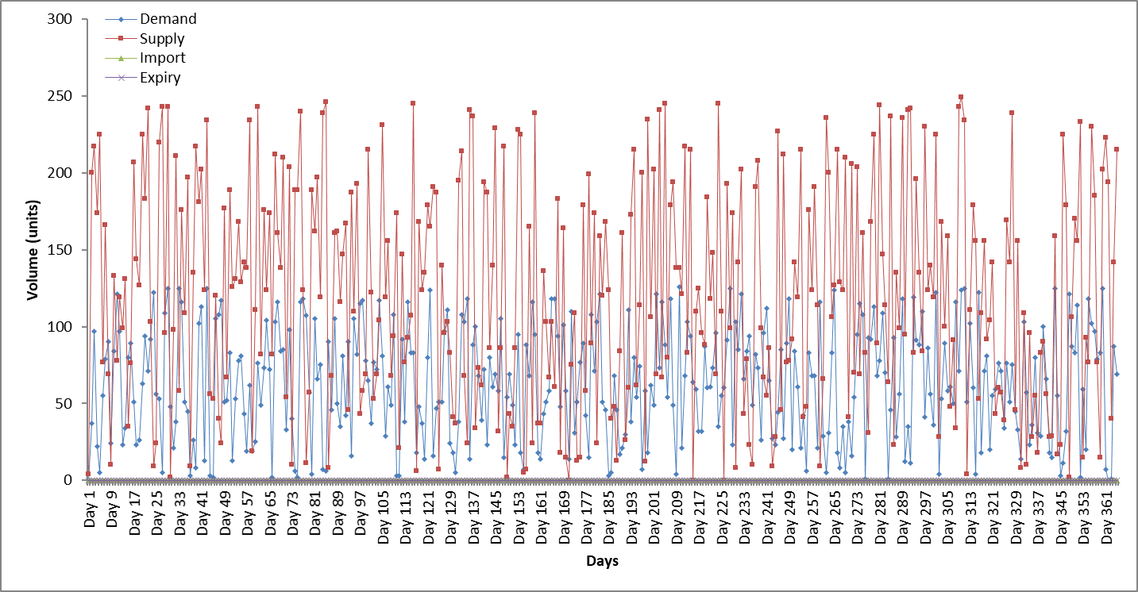

Fig. 23: Represents a line graph over a period of 365 days for the GA implementation of dataset 4

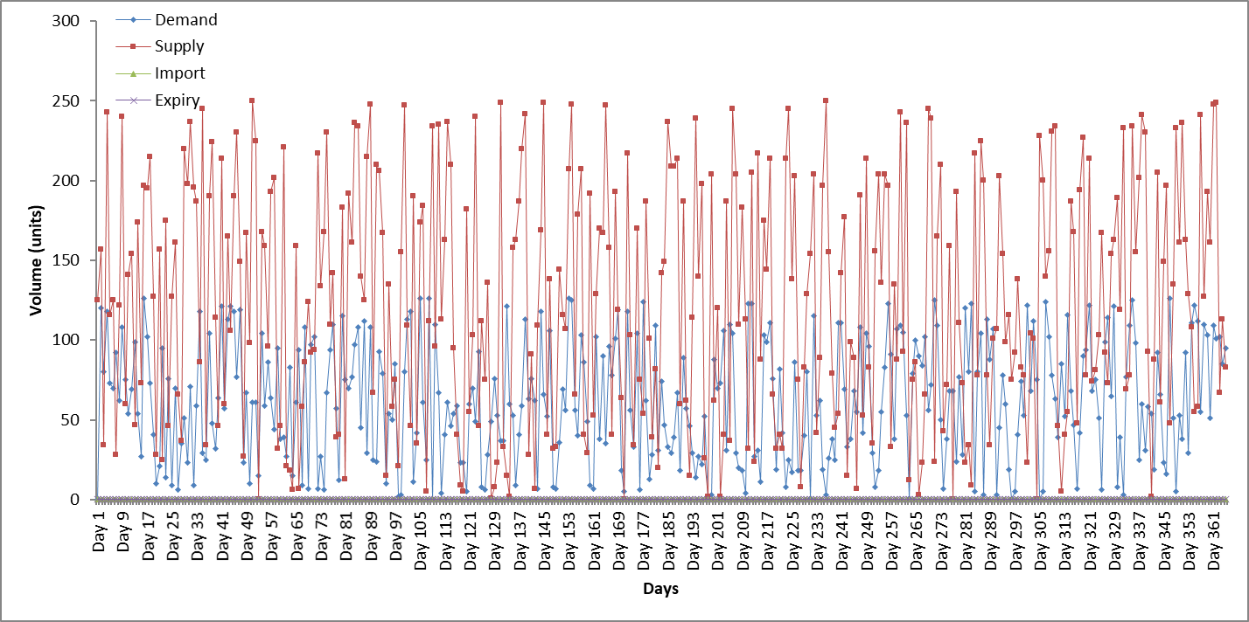

Fig. 24: Represents a line graph over a period of 365 days for the PSO implementation of dataset 4

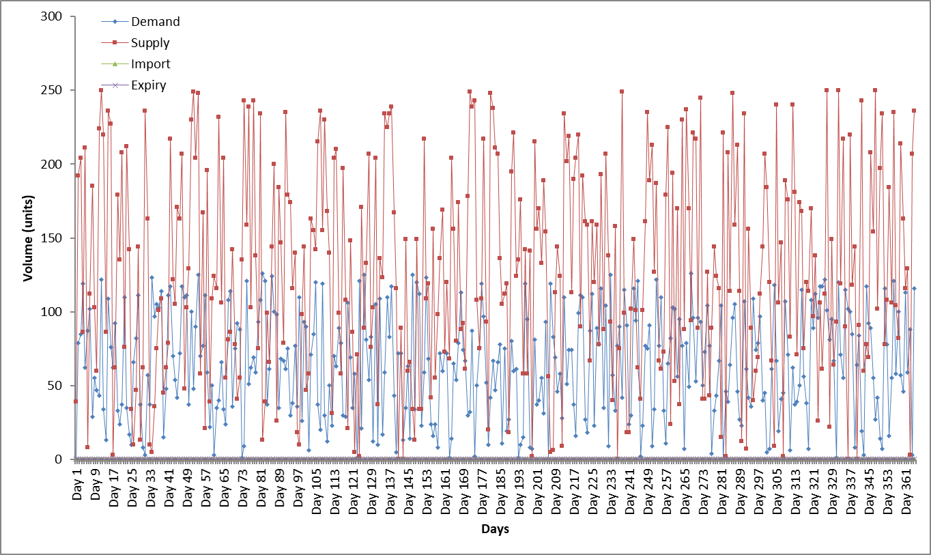

Fig. 25: Represents a line graph over a period of 365 days for the PSO implementation of dataset 4

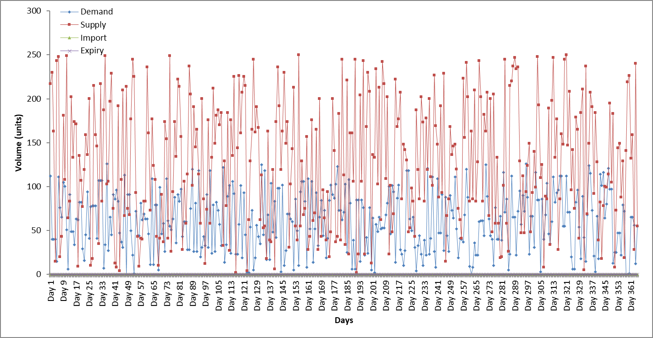

Fig. 26: Represents a line graph over a period of 365 days for the SOS implementation of dataset 4

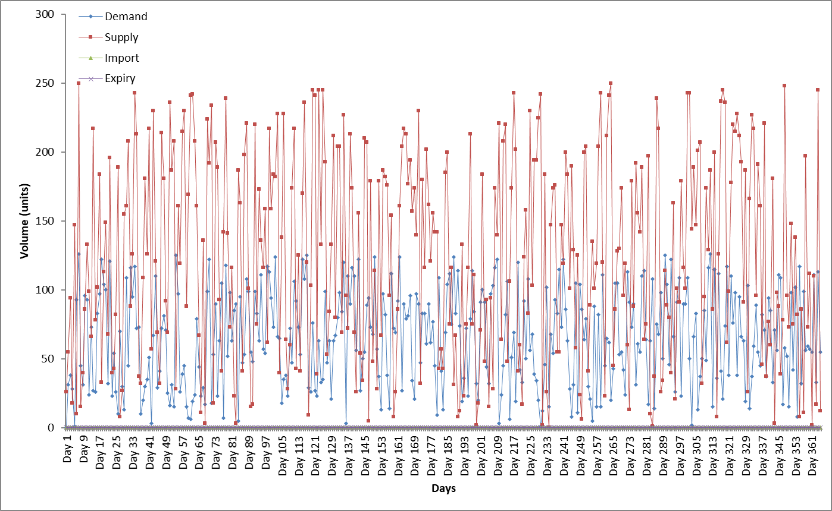

Fig. 27: Represents a line graph over a period of 365 days for the GWO implementation of dataset 4

**Discussion for dataset 4**

Dataset 4 tested the opposite of dataset 3, as the percentage bounds for generating supply greatly outweighed the bounds for generating demand. In theory, the levels of expiry was expected to drastically increase. However after analysing the results, no form of expiry occurred due to the 30 lifespan of WB units. Practically it is very unrealistic for a WB unit to stay in storage for its allotted lifespan unless demand is virtually non-existent. Dataset 4 revealed that all the algorithms shared similar graphical shapes with the supply trend exceeding the demand trend. In addition, none of the algorithms experienced importation or expiration with similar computational times as compared to dataset 1. Taking these factors into account, all algorithms performed efficient when subjected to dataset 4.

**4.2.5 Dataset 5**

A blood bank can be subjected to a mass collection of WB units, which is what dataset 5 examines. The percentage bounds used for demand and supply replicate the bounds used in dataset 1, but utilised 5000 WB units as an initial volume instead of 500 units.

**Table 16**: Average results achieved for each metaheuristic implementation subjected to dataset 5 for each blood group measured in units.

|  |  |  |  |  |  |  |  |  |  |
| --- | --- | --- | --- | --- | --- | --- | --- | --- | --- |
| **MT** | **Variable** | **A+** | **A-** | **B+** | **B-** | **AB+** | **AB-** | **O+** | **O-** |
| **GA** | **Supply** | 5205.15 | 816.14 | 1952.03 | 320.22 | 485.21 | 159.66 | 6334.86 | 1136.78 |
|  | **Demand** | 383.20 | 59.87 | 143.70 | 23.95 | 35.92 | 11.97 | 467.02 | 83.82 |
|  | **Import** | 1.88 | 0.31 | 0.70 | 0.10 | 0.28 | 0.06 | 2.31 | 0.39 |
|  | **Expiry** | 0.00 | 0.00 | 0.00 | 0.00 | 0.00 | 0.00 | 0.00 | 0.00 |
| **PSO** | **Supply** | 3331.25 | 80.35 | 1264.40 | 40.95 | 307.45 | 106.53 | 503.23 | 108.92 |
|  | **Demand** | 397.69 | 62.14 | 149.13 | 24.86 | 37.28 | 12.43 | 484.68 | 86.99 |
|  | **Import** | 46.06 | 14.62 | 5.68 | 5.70 | 6.45 | 0.40 | 129.94 | 19.75 |
|  | **Expiry** | 0.00 | 0.00 | 0.00 | 0.00 | 0.00 | 0.00 | 0.00 | 0.00 |
| **DA** | **Supply** | 3442.04 | 1749.02 | 1325.24 | 674.90 | 310.58 | 108.34 | 2190.95 | 1773.78 |
|  | **Demand** | 396.28 | 61.92 | 148.60 | 24.77 | 37.15 | 12.38 | 482.97 | 86.69 |
|  | **Import** | 2.87 | 0.15 | 0.57 | 0.00 | 1.91 | 0.03 | 2.24 | 0.09 |
|  | **Expiry** | 0.00 | 0.00 | 0.00 | 0.00 | 0.00 | 0.00 | 0.00 | 0.00 |
| **SOS** | **Supply** | 2404.66 | 1184.73 | 882.15 | 438.40 | 238.29 | 86.86 | 1639.28 | 1220.06 |
|  | **Demand** | 397.86 | 62.17 | 149.20 | 24.87 | 37.30 | 12.43 | 484.89 | 87.03 |
|  | **Import** | 0.00 | 0.00 | 0.00 | 0.00 | 0.62 | 0.00 | 0.00 | 0.00 |
|  | **Expiry** | 0.00 | 0.00 | 0.00 | 0.00 | 0.00 | 0.00 | 0.00 | 0.00 |
| **GWO** | **Supply** | 637.34 | 252.61 | 230.45 | 70.28 | 19.65 | 17.99 | 771.21 | 161.06 |
|  | **Demand** | 424.51 | 66.33 | 159.19 | 26.53 | 39.80 | 13.27 | 517.38 | 92.86 |
|  | **Import** | 7.73 | 0.21 | 6.15 | 0.39 | 20.15 | 0.93 | 5.22 | 0.00 |
|  | **Expiry** | 0.00 | 0.00 | 0.00 | 0.00 | 0.00 | 0.00 | 0.00 | 0.00 |

|  |  |  |
| --- | --- | --- |
| Metaheuristic | Time (Ms) | Time(Minutes) |
| GA | 4422080 | 73.70 |
| PSO | 504499 | 8.40 |
| DA | 4203022 | 70.05 |
| SOS | 5805914 | 96.76 |
| GWO | 4385240 | 73.09 |

**Table 17:** Running time per metaheuristic for dataset 5

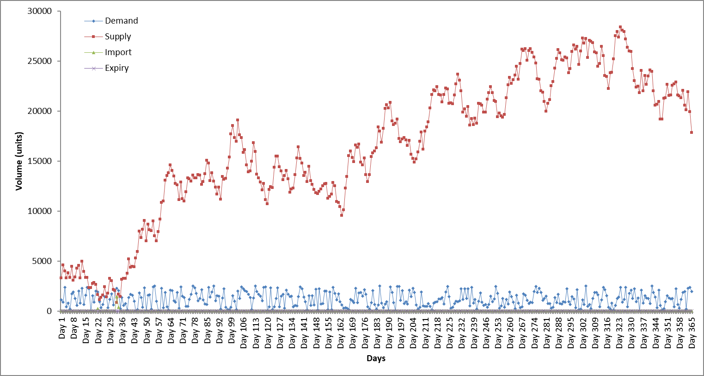

Fig. 28: Represents a line graph over a period of 365 days for the GA implementation of dataset 5

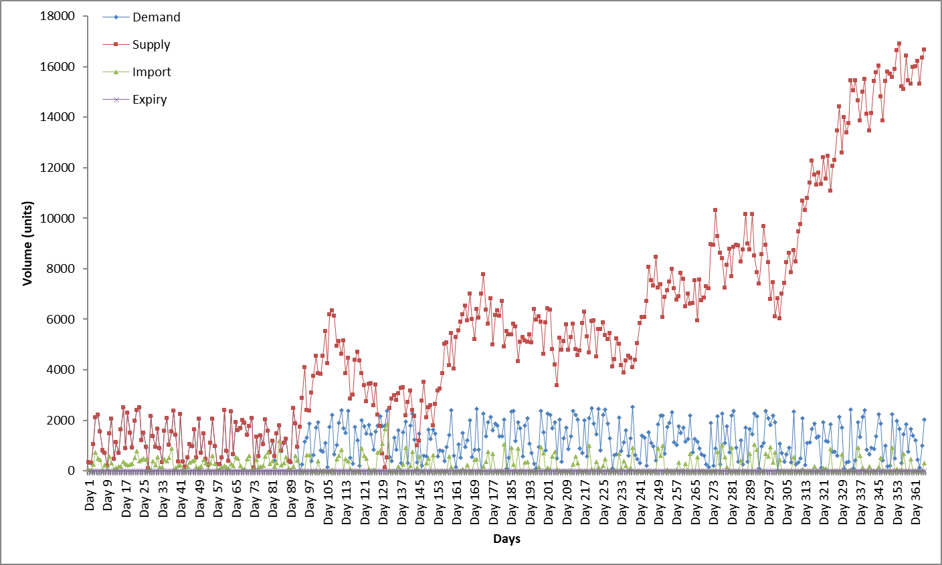

Fig. 29: Represents a line graph over a period of 365 days for the PSO implementation of dataset 5

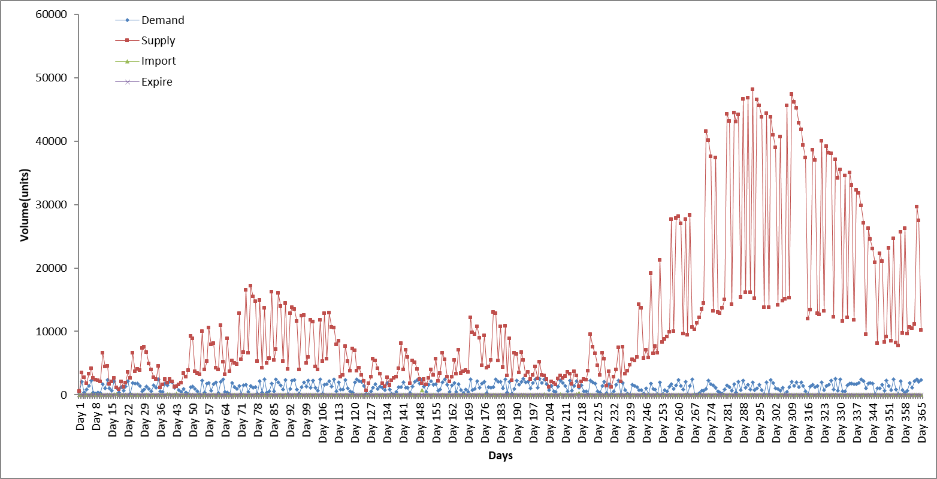

Fig. 30: Represents a line graph over a period of 365 days for the DA implementation of dataset 5

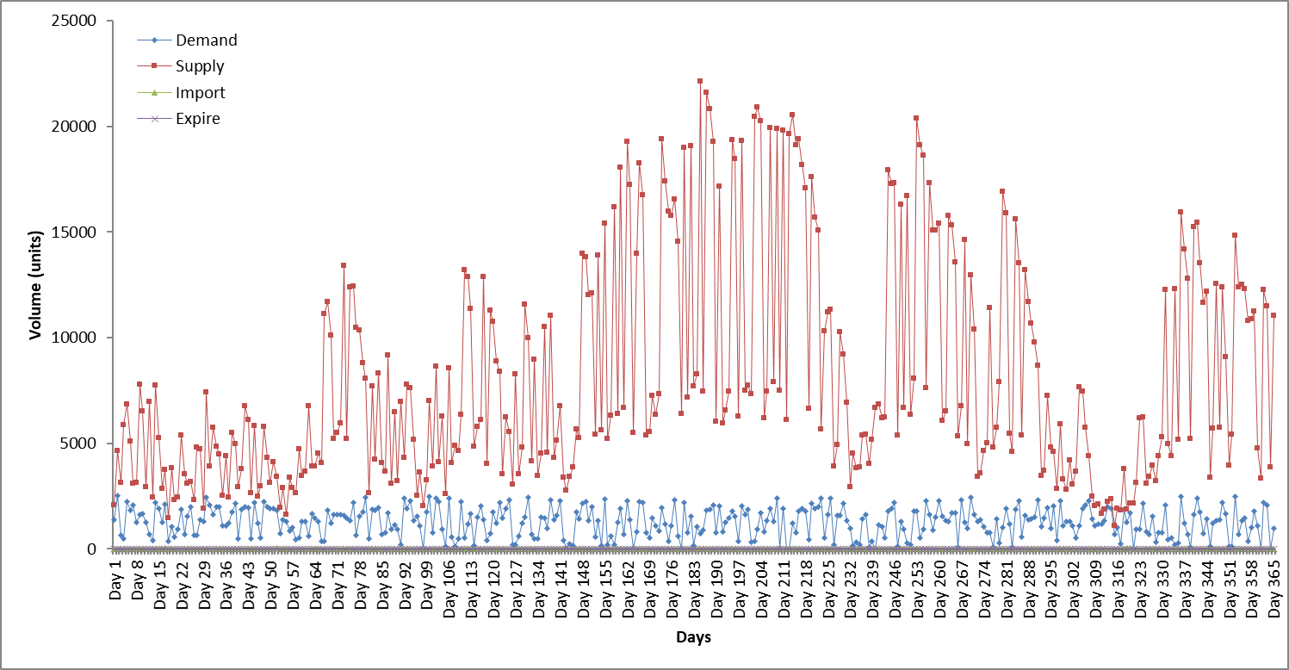

Fig. 31: Represents a line graph over a period of 365 days for the SOS implementation of dataset 5

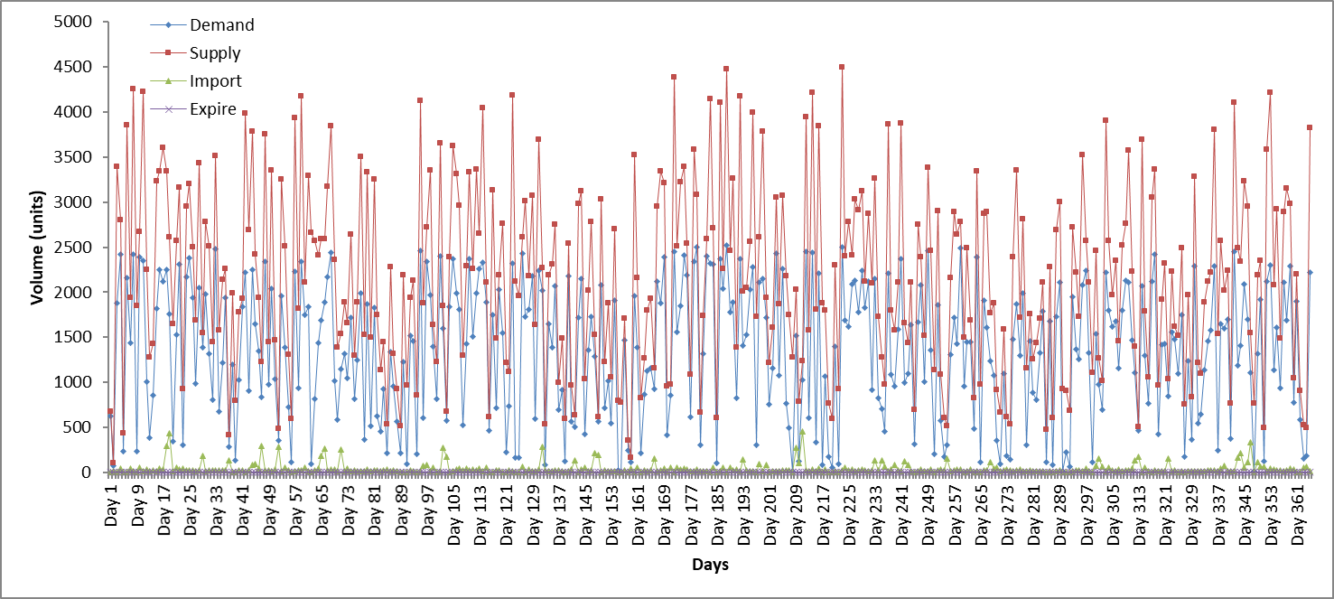

Fig. 32: Represents a line graph over a period of 365 days for the GWO implementation of dataset 5

**Discussion of dataset 5**

Dataset 5 was a replica of dataset 1 in the aspect of percentage bounds for demand and supply. The only difference lay in the initial volume of blood units which was 5000 units. This tested how well a blood bank was able to efficiently distribute large volumes of WB units. As expected the average levels for demand and supply increased accordingly. The increase in WB volume had very little affect on the computational time for the algorithms, and no form of expiry occurred.

* GA in proportion to the large volume of WB units, experience very low amounts of importation, and similar to dataset 1 experienced stock-piling at a very early stage (approximately day 35). After stock-piling, there were no visible forms of importation experienced throughout the remainder of the time frame.
* PSO delivered very high importation levels especially for blood types A+ and O+ with stock-piling occurring around day 150. Similar to dataset 1, the PSO algorithm still imported WB units even after stock-piling occurred.
* The DA was similar to the GA in that the importation levels were quite low with blood type B- experiencing no form of imports. Stock-piling occurred around day 240 after which the supply trends followed the same fluctuating pattern as compared to dataset 1.
* SOS system posed the largest of change in comparison to dataset 1. The algorithm experienced stock-piling from day 1 which resulted in no form of importation except for blood type AB+.
* GWO followed its typical sporadic graphical trend with no stock-piling occurring within the timeframe, as such the GWO implementation incurred imports for specific blood types throughout the allotted time frame.

Dataset 1 used an initial volume of 500 WB units, whilst dataset 5 used 5000 units. Even though there was a drastic difference between the initial blood unit volume, most algorithms displayed similar behaviour and graphical trends. The SOS was by far the most effective algorithm with almost no form of importation and was the fastest to reach the effect of stock-piling.

**4.2.6 Dataset 6**

Since this study’s aim relates to incorporating SAGV for stochastically generating demand and supply, the introduction of dataset 6 seemed imperative. Dataset 6 follows the same demand bounds of dataset 2, but utilises a higher initial WB unit volume of 5000 units.

**Table 18**: Average results achieved for each metaheuristic implementation subjected to dataset 6 for each blood group measured in units.

|  |  |  |  |  |  |  |  |  |  |
| --- | --- | --- | --- | --- | --- | --- | --- | --- | --- |
| **MT** | **Variable** | **A+** | **A-** | **B+** | **B-** | **AB+** | **AB-** | **O+** | **O-** |
| **GA** | **Supply** | 17293.71 | 2700.27 | 6485.94 | 1082.13 | 1619.56 | 536.04 | 21076.53 | 3779.62 |
|  | **Demand** | 345.93 | 54.05 | 129.72 | 21.62 | 32.43 | 10.81 | 421.60 | 75.67 |
|  | **Import** | 0.73 | 0.11 | 0.28 | 0.05 | 0.07 | 0.03 | 0.90 | 0.16 |
|  | **Expiry** | 0.00 | 0.00 | 0.00 | 0.00 | 0.00 | 0.00 | 0.00 | 0.00 |
| **PSO** | **Supply** | 10808.48 | 59.98 | 4047.42 | 24.02 | 1011.76 | 334.79 | 467.84 | 83.99 |
|  | **Demand** | 351.56 | 54.93 | 131.84 | 21.97 | 32.96 | 10.99 | 428.47 | 76.90 |
|  | **Import** | 0.29 | 17.44 | 0.11 | 6.96 | 0.03 | 0.01 | 136.02 | 24.41 |
|  | **Expiry** | 0.00 | 0.00 | 0.00 | 0.00 | 0.00 | 0.00 | 0.00 | 0.00 |
| **DA** | **Supply** | 15915.12 | 7070.80 | 5962.89 | 2671.17 | 1466.52 | 489.37 | 7503.44 | 7096.10 |
|  | **Demand** | 344.48 | 53.82 | 129.18 | 21.53 | 32.29 | 10.76 | 419.83 | 75.35 |
|  | **Import** | 0.90 | 0.00 | 0.24 | 0.00 | 0.29 | 0.00 | 0.88 | 0.00 |
|  | **Expiry** | 0.00 | 0.00 | 0.00 | 0.00 | 0.00 | 0.00 | 0.00 | 0.00 |
| **SOS** | **Supply** | 5157.35 | 914.22 | 2439.90 | 430.83 | 549.99 | 206.36 | 7621.29 | 1389.61 |
|  | **Demand** | 354.62 | 55.41 | 132.98 | 22.16 | 33.25 | 11.08 | 432.20 | 77.57 |
|  | **Import** | 0.00 | 0.00 | 0.00 | 0.00 | 0.18 | 0.00 | 0.00 | 0.00 |
|  | **Expiry** | 0.00 | 0.00 | 0.00 | 0.00 | 0.00 | 0.00 | 0.00 | 0.00 |
| **GWO** | **Supply** | 830.88 | 360.82 | 292.25 | 106.79 | 14.26 | 23.18 | 963.91 | 205.18 |
|  | **Demand** | 349.75 | 54.65 | 131.16 | 21.86 | 32.79 | 10.93 | 426.26 | 76.51 |
|  | **Import** | 4.83 | 0.04 | 7.61 | 0.35 | 38.30 | 1.14 | 7.45 | 0.00 |
|  | **Expiry** | 0.00 | 0.00 | 0.00 | 0.00 | 0.00 | 0.00 | 0.00 | 0.00 |

**Table 19**: Running time per metaheuristic for dataset 6

|  |  |  |
| --- | --- | --- |
| Metaheuristic | Time (Ms) | Time(Minutes) |
| GA | 4321070 | 72.017 |
| PSO | 503324 | 8.38 |
| DA | 4302052 | 71.70 |
| SOS | 5906312 | 98.43 |
| GWO | 4362574 | 72.70 |

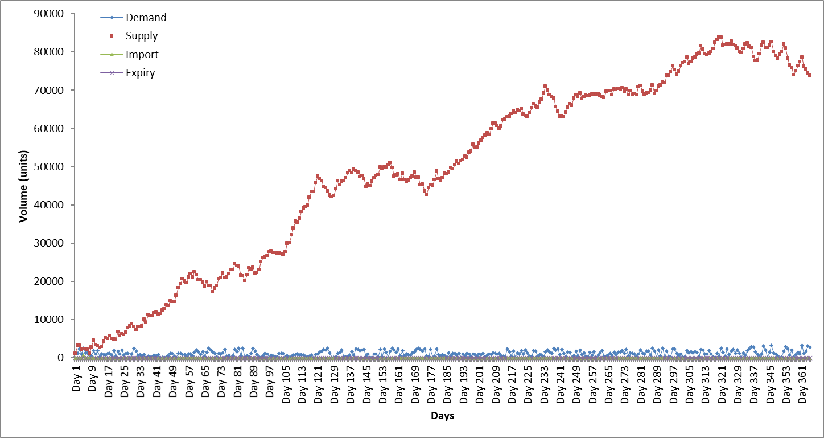

Fig. 33: Represents a line graph over a period of 365 days for the GA implementation of dataset 6

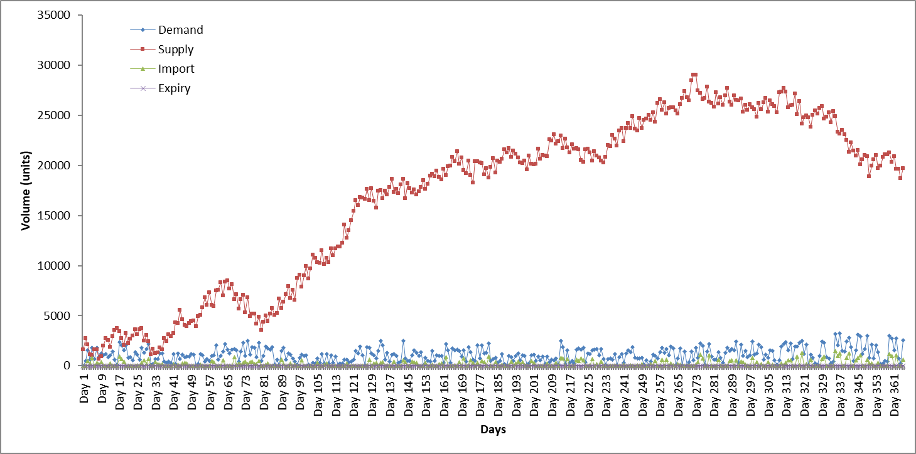

Fig. 34: Represents a line graph over a period of 365 days for the PSO implementation of dataset 6

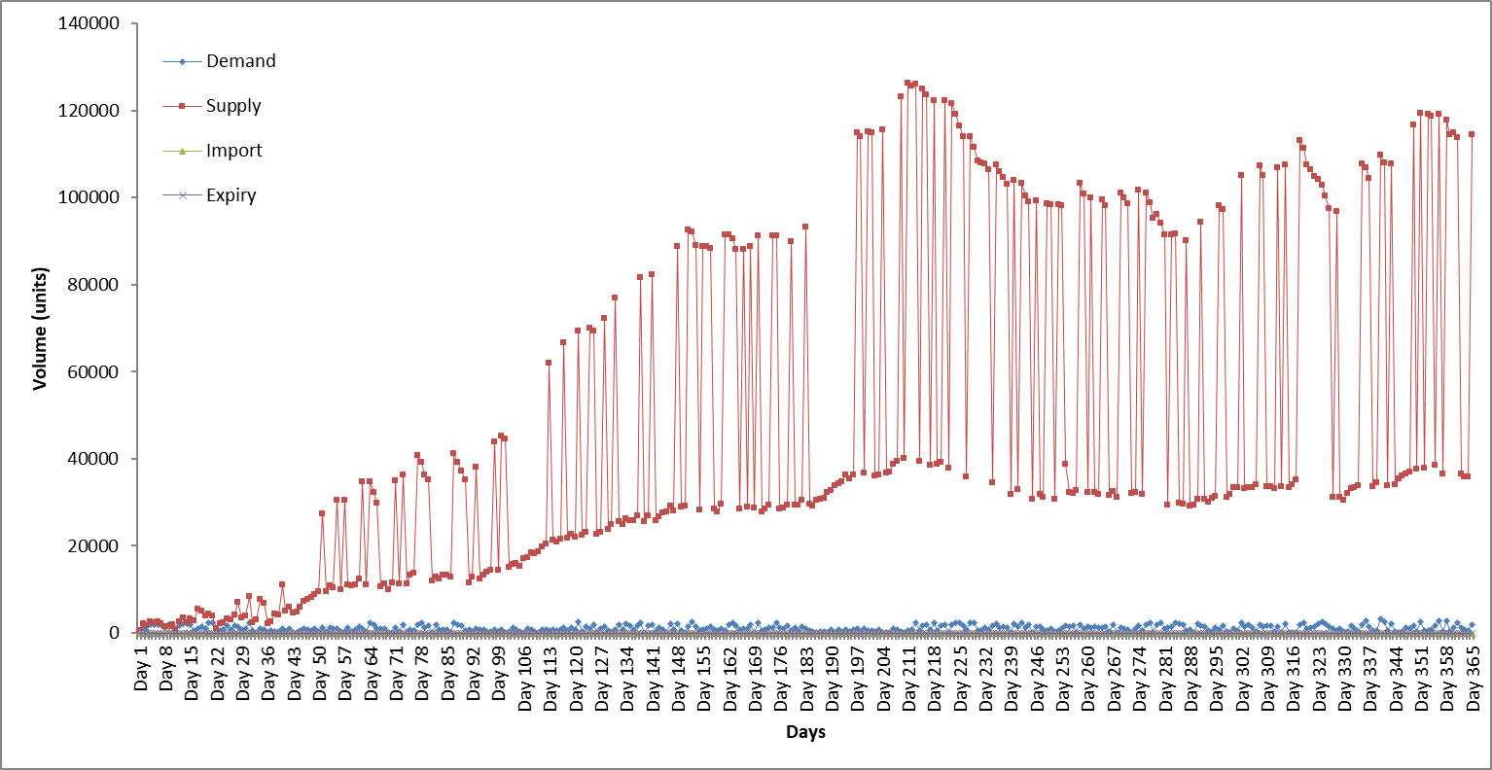

Fig. 35: Represents a line graph over a period of 365 days for the DA implementation of dataset 6

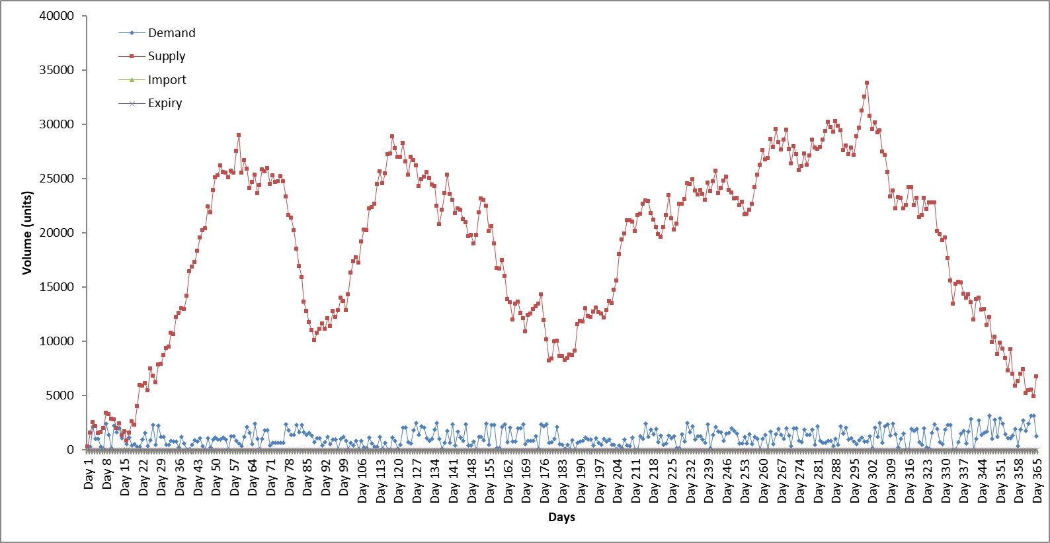

Fig. 36: Represents a line graph over a period of 365 days for the SOS implementation of dataset 6

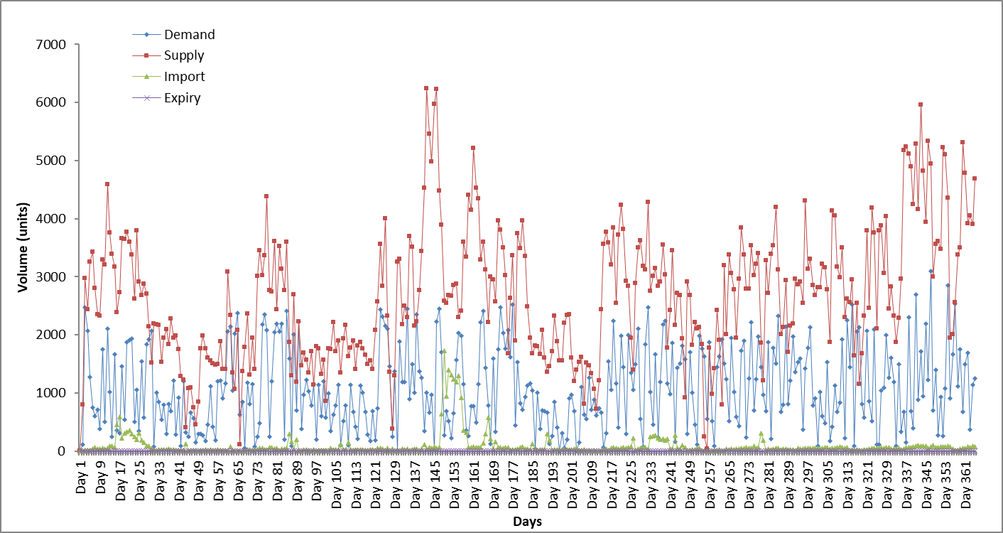

Fig. 37: Represents a line graph over a period of 365 days for the GWO implementation of dataset 6

**Discussion of dataset 6**

The last analysis of results relate to dataset 6. Dataset 6 was a replica of dataset 2 in term of percentage bounds, but was similar to dataset 5 in testing a larger volume of WB units. Due to the percentage bounds being generated by South African statistics on a monthly basis, the demand and supply averages were expected to decrease.The results are as follows

* GA performed efficiently, with stock-piling occurring around day 14, but did experience relatively high importation amounts before stockpiling occurred. Overall the average importation levels for each blood type is relatively small in comparison to the initial volume of WB units.
* The results obtained from the PSO algorithm was a large improvement than the previous dataset 5 results. However, blood type O+ still experienced very large importation levels throughout the time period. The algorithm did experience stock piling around day 35, but similar to the previous datasets sporadic amounts of importation still occurred even though the event of stock-piling occurred.
* For the DA implementation, blood types A+, B+, AB+ and O+ were the only types to experience importation, however these values where relatively small. The algorithm experienced stock-piling around day 40, and followed its fluctuating supply trend thereafter.
* Unlike dataset 5, the SOS algorithm did not experience stockpiling from the day 1, but rather around day 17. After stock-piling occurred, no form of importation was experienced. Similar to dataset 5, the only blood type to experience importation was type AB+
* In previous datasets, the GWO did not experience any form of stock-piling. However dataset 6 reveals small periods of stock-piling which could be due to the unique nature of WB unit demand generation. This is an improvement as stock-piling decreased the overall importation experienced for each blood type.

Even though the SOS algorithm was the second fastest to experience stock-piling, it was still considered as the best algorithm for dataset 6. SOS experienced no form of importation, except for blood type AB+

**4.3 Comparison between demand generations**

As emphasized in previous chapters, this study incorporated a method for generating values for WB unit demands by incorporating statistics from South Africa. Previous literatures used fixed percentage bounds over a set time frame, which was illustrated in this study by dataset 1. As proven by the results analysed in dataset 1 and 2, the average demand and supply per blood type in dataset 2 is smaller due to unique percentage bounds allocated to each month instead of a constant percentage bound used in dataset 1. The statistics used to generate dataset 2 includes public holidays and breaks from educational institutions within South Africa. The ideology behind using such statistics tries to emphasize the fact that WB units would have a higher demand in months which experience an increase in dangerous activities such as drinking and driving, criminal events etc. Therefore this section serves as an analysis between the results obtained from generating demand values between the two mentioned methods. Below are 5 line graphs (fig 38-42) depicting the curvature of demand generation using the fixed percentage bound in comparison to the SAGV method per metaheuristic algorithm.

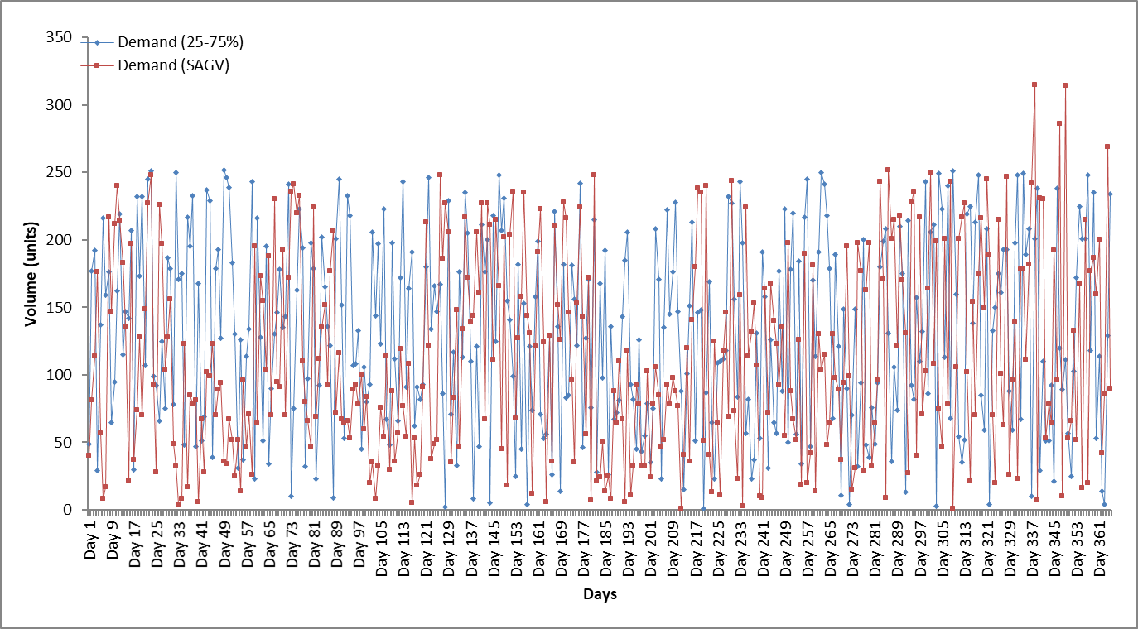

Fig. 38: Represents a comparison between demand generations for GA

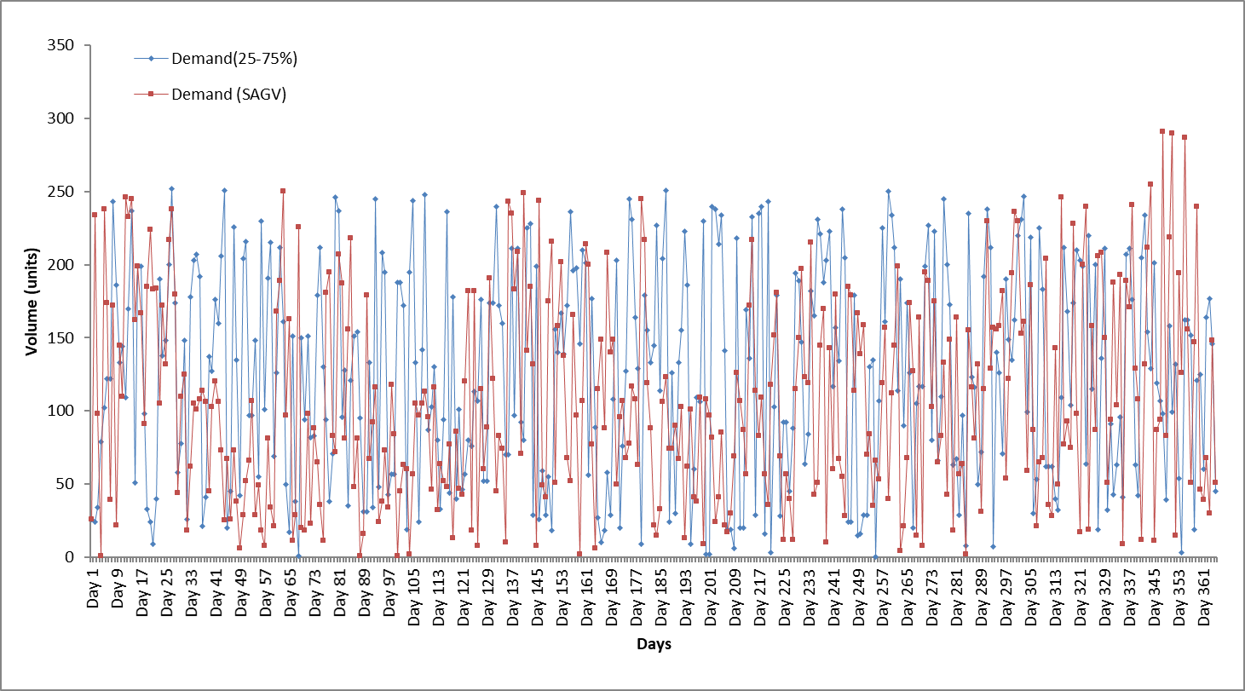

Fig. 39: Represents a comparison between demand generations for PSO

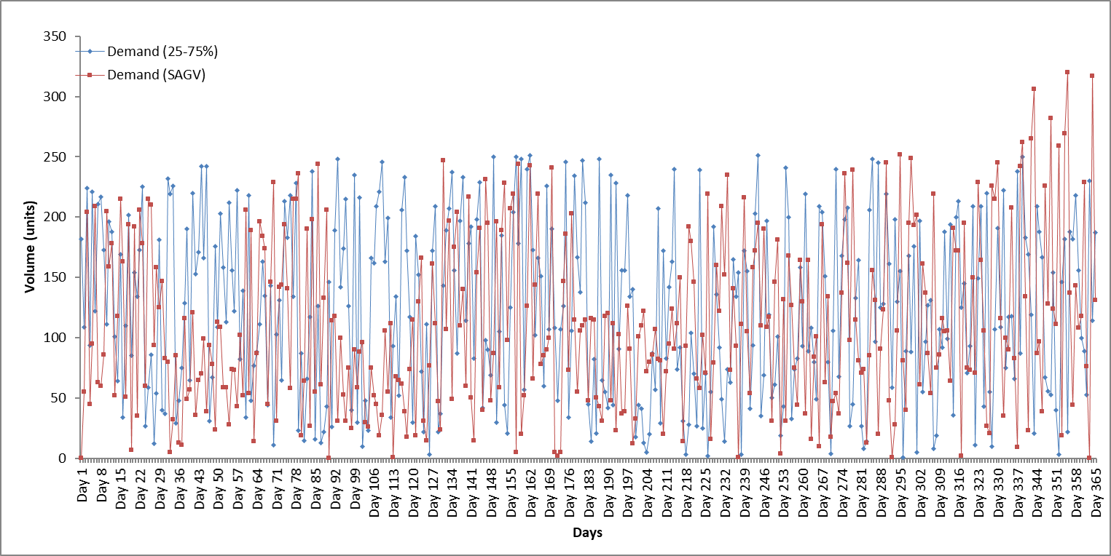

Fig. 40: Represents a comparison between demand generations for DA

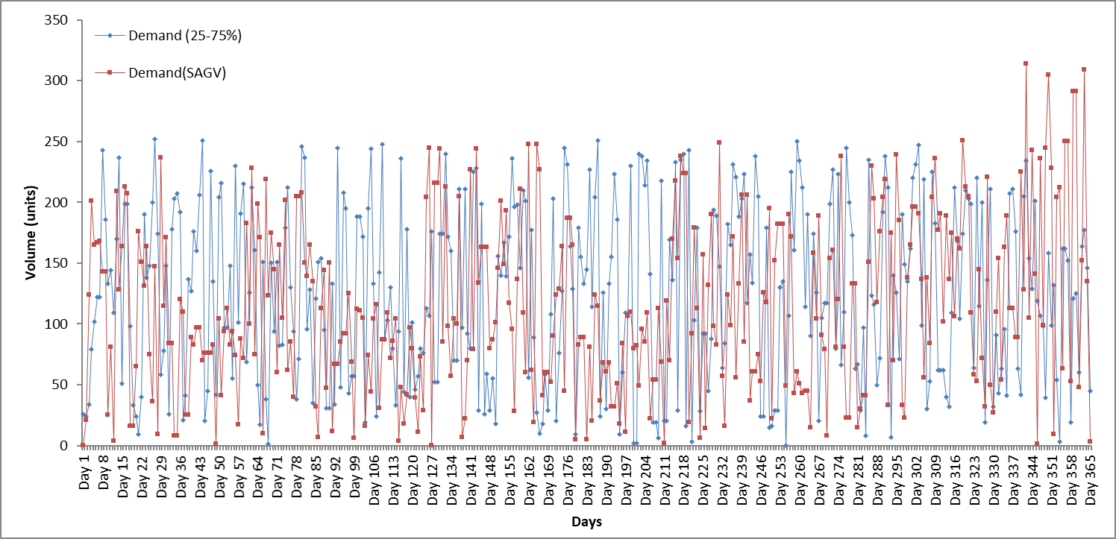

Fig. 41: Represents a comparison between demand generations for SOS

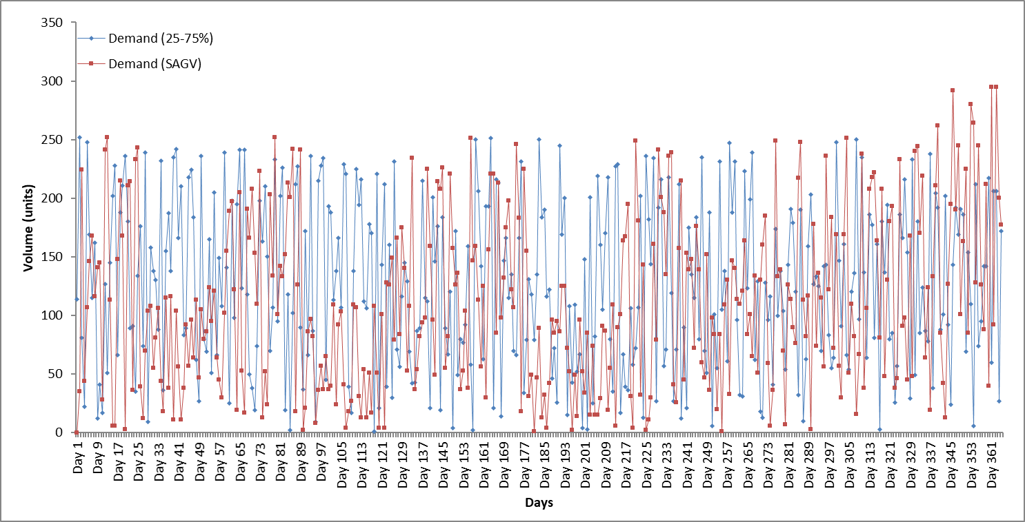

Fig. 42: Represents a comparison between demand generations for GWO

Fig. 38-42 represent line graphs depicting the demand generated using fixed percentage bounds versus bounds generated using SAGV. A noticeable component relating to a fixed percentage bound relates to the absolute randomness in regards to the line trend, whereas the trend based on SAGV seems to have periods with high and low variations. With reference to SAGV, around days 28-55 (represents February) across all figures indicate that the demand for WB units is generally lower, which correlates to the assumption that months with fewer public holidays and breaks from educational institutions should utilise fewer WB units. The opposite assumption relates to high WB unit demand which is clearly depicted in a month like December (days 331-365) which illustrates a much higher demand curvature.

**5. Conclusion and Future Work**

This study looked at the applications of metaheuristics algorithms coupled with a mathematical model to solve the BAP. Each of the algorithms were subjected to stochastically generated datasets which tested various scenarios that could be imposed upon the blood bank. In addition, this study incorporated South African statistics when generating some of the datasets. This method of dataset generation tries to reduce the randomness when generating values, and contribute towards the study of blood management or other related perishable inventory problems. Prior literatures merely allocated percentage bounds to each dataset, and did not incorporate any relevant statistics when generating these bounds. The following table illustrates the best algorithm per dataset.

Table: Represents the best algorithms in association to each dataset

|  |  |
| --- | --- |
| **Dataset** | **Best Algorithm** |
| 1 | SOS |
| 2 | GA |
| 3 | SOS |
| 4 | GA, PSO, DA, SOS, GWO |
| 5 | SOS |
| 6 | SOS |

It can be concluded that the SOS algorithm outperforms the other implementations. Whilst the SOS algorithm is by no means the fastest, its results of low importation levels and no form of expiry makes up for its lack of speed. The PSO algorithm was deemed as the fastest for producing an output, but suffered with constant low-level imports even after stockpiling occurred. GA and DA did not report significant results, however the GA did perform the best when exposed to dataset 2, indicating that the GA performs well when exposed to SAGV. The worst algorithm was the GWO due to no form of consistent stock-piling across any of the datasets. The GA and PSO algorithms were implemented in previous literature by [3] and [7] respectively. The study conducted by [3] implemented various hybrid implementations of the GA as well as the HC algorithm, and reported that the HC outperformed the other implementations. With reference to the results obtained by [7], the PSO algorithm seemed to perform well in producing low importation levels, however the algorithm was only run over a course of 90 days and did not no incorporate the same model of adding the previous days remainder to the current day’s supply, thus the findings in this study cannot be compared to the research conducted by [7]. Overall this study has furthered the research relating to the BAP by implementing newer metaheuristics namely the DA, SOS and GWO, and incorporated a steadier method of stochastically generating datasets which can contribute to other relatable inventory management problems. In addition, certain ideas from previous literatures were expanded upon in this study in order to build a more accurate mathematical model.

Future work can try and obtain real-world datasets to test their implementations. If datasets are still being stochastically generated, then work can go into utilising even more statistics when allocating percentage bounds to each month. The mathematical model can also be improved upon, for example certain procedures require blood of that patient’s specific blood type, this accessory could be implemented in future research. Finally, the field of metaheuristics is an ever expanding area, due to this even more metaheuristic algorithms can be tailored for the BAP.

**References**

[1]: Hess. S, Coullard. C., Daskin. M, Hurter. A, (1997), A case study in platelet inventory management. In Proceedings of the 6th Industrial Engineering Research Conference. Atlanta: Institute of Industrial Engineers (pp. 801-6).

[2]: Basu. D, Kulkarni. R, (2018), Overview of blood components and their preparation, Department of pathology and transfusion medicine, Pondicherry, India

[3]: Adewumi, A., Budlender, N. and Olusanya, M., (2012), June. Optimizing the assignment of blood in a blood banking system: some initial results. In Evolutionary Computation (CEC), 2012 IEEE Congress on (pp. 1-6). IEEE.

[4]: Kaveh. A, Ghobadi. M, (2015), A multistage algorithm for blood banking supply chain allocation problem, University of Science and Technology, Iran.

[5]: South African National Blood Service, Product Price List, Available at: https://sanbs.org.za/product-price-list/, accessed on [17-07-2018]

[6]: Haijema. R, Wal. J, van Dijk. N, (2005), Blood platelet production: Optimization

by dynamic programming and simulation, Department of Quantitative Economics,

Amsterdam, Netherlands

[7]: Olusanya. O, Arasomwan. MA, Adewumi AO, (2014), Particle swarm optimization algorithm for optimizing assignment of blood in blood banking system, University of KwaZulu Natal, School of Mathematics, statistics and computer science, Durban, South Africa

[8]: Adewumi. A.O, (2014), Using metaheuristics techniques to optimize the blood assignment problem, University of KwaZulu Natal, School of Mathematics, statistics and computer science, Durban, South Africa

[9]: Giangrande. P.L.F, (2001), The history of blood transfusion, Oxford Haemophilia centre, Oxford, United Kingdom.

[10]: Reid. M.E, Lomas-Francis. C, (2004), The blood group antigen Fac-Book, (3rd ed), Academic Press

[11]: Albdulwahab U.S, (1996), blood platelet bank inventory management: an approximate dynamic programming approach, KAA university, Saudi Arabia.

[12]: Hardwick. J, (2008), Blood storage and transportation, ISBT science series vol.3, pp. 177-196.

[13]: Chaudhari. C.N, (2008), Frozen red blood cells in transfusion, INHS Jeevanti, India, MJAFI vol 65, issue 1, pp.55-58.

[14]: Sorensen. K, Metaheuristics- The metaphor exposed, Belgium, International Transactions in operational research, pp. 3-18.

[15]: Radalo. A, Pillay. N, (2017), An investigation of dynamic fitness measure for genetic programming. Expert systems with application, pp.52-72.

[16]: Pillay. N, (2013), A survey of school timetabling research, School of Computer Science, University of KwaZulu-Natal, Pietermaritzburg, South Africa, Spring Science+business media.

[17]: Dias. T, Sousa. J, Cunha. J, (2001), A Genetic Algorithm for the Bus Driver Scheduling Problem, Portugal, Porto, The Journal of the Operational Research Society Vol 53 issue 3, pp. 324-335.

[18]: Bonyadi. M.R, Michalewicz. Z, (2017), Particle swarm optimization for single objective continuous space problems: A review, Massachusetts Institute of Technology, Massachusetts, United states of America, Evolutionary Computation vol 25, issue. 1, pp.1-54.

[19]: Liu. Zhixiong, (2007), Investigation of Particle Swarm Optimization for Job Shop Scheduling Problem, Haikou, China, Third International Conference on Natural Computation vol 5.

[20]: Biyanto. T.R, Fibrianto H.Y, Nugroho G, Listijorini E, Budiati T, Huda H, (2016), Duelist Algorithm: An algorithm by how duelist improve their capabilities in a duel, Indonesia.

[21]: Biyanto. T.R, Fibrianto H.Y,(2016), Duelist Algorithm: An Algorithm in Stochastic Optimization Method, Research Center for Metrology - The Indonesian Institute of Sciences Lembaga Ilmu Pengetahuan Indonesia (LIPI), Jakarta, Indonesia

[22]:Ezugwu. A.E, Adeleke. O.J, Viriri. S, (2018), Symbiotic organisms search algorithm for the unrelated parallel machines scheduling with sequence-dependent setup times, University of KwaZulu Natal, School of Mathematics, statistics and computer science, Durban, South Africa, PLOS ONE

[23]: Cheng M.Y., Prayogo D. and Tran D.H., (2015). Optimizing multiple-resources leveling in multiple projects using discrete symbiotic organisms search. Journal of Computing in Civil Engineering, 30(3), p.04015036.

[24]: Venkatakrishnan. G.R, Rengaraj. R, Salivahanan. S, (2018), Grey Wolf Optimizer to Real Power Dispatch with Non-Linear Constraints, Department of Electrical and Electronics Engineering, SSN College of Engineering, Chennai, India, CMES vol 115 issue 1, pp 25-45.

[25]: Goodnough. L.T, Shander. A, (2012), Patient blood management, Departments of Pathology and Medicine, Stanford University School of Medicine, Stanford, California, Anesthesiology vol. 116, pp. 1367-1376

[26]: Banthao. J, Phongchai. J, (2012), An analysis of alternative blood bank locations with emergency referral, San Francisco, United states of America, Proceedings of the world congress on Engineering and Computer Science vol. 2, pp. 978-988.

[27]: Rusman. M, Rapi. A, (2014), Blood banks location model for blood distribution planning in Makassar City, Department of Industrial Engineering Hasanuddin University, Makassak.

[28]: Igwe. K, Adewumi. A.O, (2013), On the performance of GRASP and dynamic programming for the blood assignment problem, University of KwaZulu Natal, School of Mathematics, statistics and computer science, Durban, South Africa.

[29]: Mid year population estimates report, (2017),Statistics South Africa, pp 1-9

[31]: https://www.worldatlas.com/articles/countries-with-the-highest-rates-of-hiv-aids.html, visited [23-07-2018]

[32]: https://www.news24.com/SouthAfrica/News/easter-road-death-toll-up-by-14-from-last-year-20180417, visited: [23-07-2018]

[33]: http://www.schoolterms.co.za/2018.html, visited: [23-07-2018]

[34]: Groth. S, (2005), Manual on the management, maintenance and use of blood cold chain equipment, World health organization, Geneva

[35]: Ragalo. A, Pillay. N, (2017), An investigation of dynamic fitness measures for genetic programming, Expert systems with applications, 52-72.

[36]: Carr. J, (2014), An introduction to genetic algorithms

[37]: Rini. D.P, Shamsuddin. S.M, Yuhaniz. S.S, (2011), Particle swarm optimization: Technique, System and Challenges, International journal of computer applications (Vol 14, No: 1), Malaysia.

[38]: Sapountzis C, (1989), Allocating blood to hospitals, Pireas graduate school of industrial studies, Greece

[39]: Prakash. S, Rajathy. R, (2015), Implementation of Symbiotic Organism Search algorithm for Extracting Maximum Power from the PV system under Partially Shaded Condition, International science press (vol 8, No:5), Pondicherry, India, pp. 1871-1880

[40]: Mirjalili S, Mirjalili S.M, Lewis. A, Grey Wolf Optimizer, (2014) School of Information and Communication Technology, Griffith University, Nathan, Brisbane, Australia and Department of Electrical Engineering, Faculty of Electrical, and Computer Engineering, Shahid Beheshti University, Tehran, Iran

[41]: Shoghian. S, Maryam. K, (2012), A Comparison among Wolf Pack Search and Four other Optimization Algorithms, faculty of Electrical Engineering Control Department University of Tabriz , Iran.